Big Data Tools and Techniques
Contents
Activity 1: Setting up a VM on Azure 1
Task 1.1: Create Azure account with free credits 1
Task 1.2: Deploy a VM with Azure Client 1
Task 1.3: Install a light Desktop environment and XRDP 1
Task 1.4: Login into your VM desktop environment 1
Task 1.5: Install google chrome on your VM 1
Activity 2: Setting up a Single Node Hadoop Cluster 1
Task 2.1: Install Java and configure profile on Ubuntu VM 1
Task 2.2: Install Hadoop 1
Task 2.3: Configure Hadoop 1
Task 2.6: Upload Sample data (1.Create sub folders in ubuntu) 1
Task 2.7: Upload Sample data (2. Copy Sample data to ubuntu subfolders) 1
Task 2.8: Upload Sample data (3. Upload data to hadoop) 1
Activity 3: Setting up a Hive 1
Task 3.1: Install and Configure Hive 1
Task 3.2: Test Beeline 1
Task 3.3: Configure MySQL as metastore 1
Task 3.4: Run Hive as a service 1
Task 3.5: Install DBeaver 1
Task 3.6: append Sample Data to MySQL 1
Activity 4: Setting up Spark, PySpark and Jupyter Notebook 1
Task 4.1: Install Spark 1
Task 4.2: Install PySpark 1
Task 4.3: Install Jupyter Notebook 1
Task 4.4: Prepare PySpark for Jupyter Notebook 1
Task 4.5: Prepare jupyter Notebook for MySQL and AzureSQL connections 1
Activity 5: Install and configure MS SQL Server /Azure SQL Server and Setup Dbeaver 1
Task 5.1: Install SQL Server 1
Task 5.2: Install SQL Server command-line tools 1
Task 5.3: Prepare a AdventureWorks sample database 1
Task 5.4: Connect to SQL Server - Dbeaver 1
Task 5.5: setup AzureSQL 1
Activity 6: Create a MongoDB Atlas free account 1
Task 6.1: Create a MongoDB Atlas free account 1
Activity 7: Install and configure Apache Airflow 1
Task 7.1: Install Apache Airflow 1
Task 7.2: Configure Apache Airflow Scheduler 1
Activity 8: Create data pipelines with Apache Airflow and PySpark 1
Task 8.1: Upload sample data to your VM 1
Task 8.2: Upload the sample Airflow DAGs to your VM 1
Task 8.3: Install necessary Python libraries 1
Task 8.4: Install Spark JDBC Connector for SQL Server 1
Task 8.5: Run the uploaded DAGs 1
Activity 9: Testing PySpark and Spark-Shell Code 1
Task 9.0: Load Sample Data 1
Task 9.1: Testing/executing PySpark code using Jupyter Notebook 1
Task 9.2: Testing/executing PySpark code nano 1
Task 9.3: Testing/executing Spark-Shell 1
Task 9.4: Testing/executing Spark-Shell-script 1
Activity 10 : Very Important 1

Activity 1: Setting up a VM on Azure

Task 1.1: Create Azure account with free credits
- You can create a free Azure account with $200 credits from the following link:
https://azure.microsoft.com/en-ca/free
- After completing the signup process, confirm the available credit balance from the Cost Management + Billing > Billing scopes > * scope
https://learn.microsoft.com/en-us/azure/cost-management-billing/manage/mca-check-azure-credits-balance?tabs=portal
- You should track your credits usage to avoid unwanted billing. Also delete resources when they are not necessary anymore.

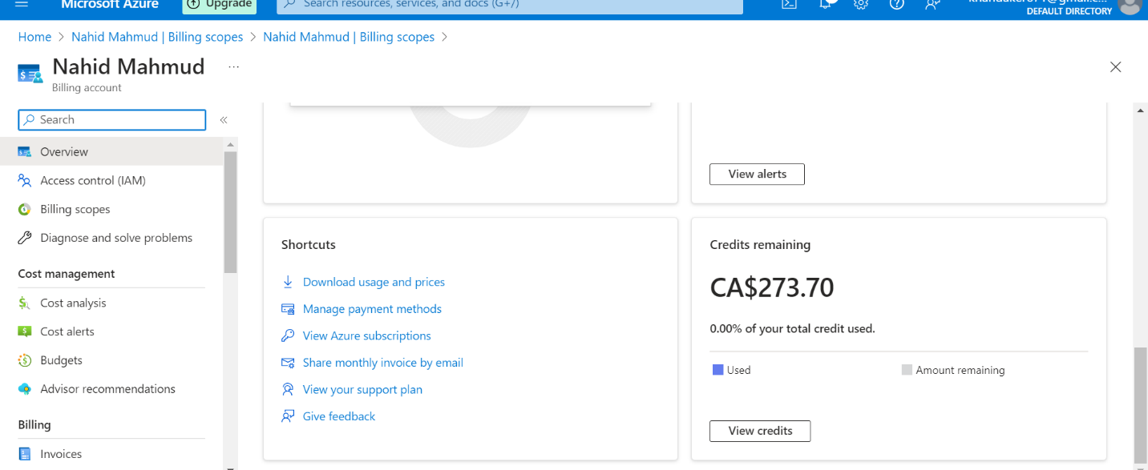

Task 1.2: Deploy a VM with Azure Client
- Install Azure CLI by following the instructions from https://learn.microsoft.com/en-us/cli/azure/install-azure-cli-windows?tabs=azure-cli
- After installation is completed, login with your Azure account in the Azure CLI. Open the PowerShell and type the following command:
az login
- After logging in, you can use the Azure CLI from PowerShell to create, delete or update your Azure resources.
=====================================================================
IMPORTANT NOTE: At any point if you need to delete/release all resources to save cost, use the following command:
az group delete --name BigDataII
=====================================================================
- First, create a resource group which will contain all your Azure resources:
az group create --name BigDataII --location eastus --tags Name=BigDataII Environment=Training
- Next, generate a ssh key which you will use to login into your virtual machine with ssh. Use the following command in PowerShell to generate the ssh key in your local machine (Press enter for default filename and provide no passphrase for ease of use)
ssh-keygen -m PEM -t rsa -b 2048
- Next create your VM. For the lab use a VM of F-series - Standard_F4s. You can find a comparison of different Azure VM sizes in the following links:
https://www.youtube.com/watch?v=zOSvnJFd3ZM
https://azure.microsoft.com/en-us/blog/f-series-vm-size/
- Use the following command to create your VM
az vm create --resource-group BigDataII --name myVM --image Canonical:0001-com-ubuntu-minimal-jammy:minimal-22_04-lts-gen2:latest --admin-username azureuser --size Standard_F4s --ssh-key-value ~/.ssh/id_rsa.pub
- Note the IP address assigned to your VM. You will need it for later uses.
(example: 20.232.160.204)
- You can also find the VM details in your Azure portal.
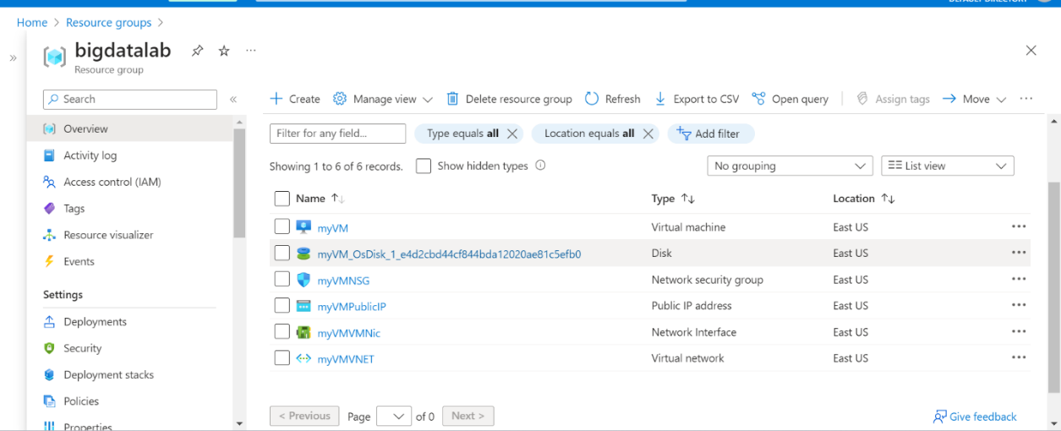

- With the above command you have created a VM named myVM. It has an admin user with the name “azureuser” and you can use the previously created ssh key for this user.
- Next, for test purposes, we will install a web server with the following command:
az vm run-command invoke -g BigDataII -n myVM --command-id RunShellScript --scripts "sudo apt-get update && sudo apt-get install -y nginx"
- Now we will open port 80 for web traffic from the internet.
az vm open-port --port 80 --resource-group BigDataII --name myVM
- To test, go to the browser and type IP address:80 (example: 20.232.160.204:80). You should see "Welcome to nginx!" It may take a few minutes for the first time.

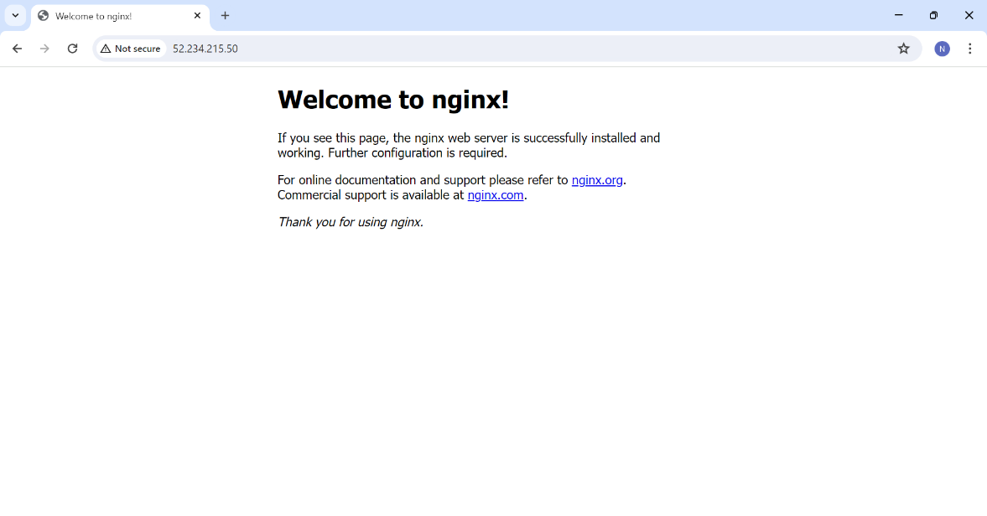
- Next, open port 3389 for Remote Desktop traffic with the following command:
az vm open-port --resource-group BigDataII --name myVM --port 3389 --priority 1100
- Now we will connect to the VM through SSH. Type the following command in your PowerShell (type yes and press enter when asked):
ssh azureuser@20.232.160.204
- You should see azureuser@myVM:~$ as the following image:
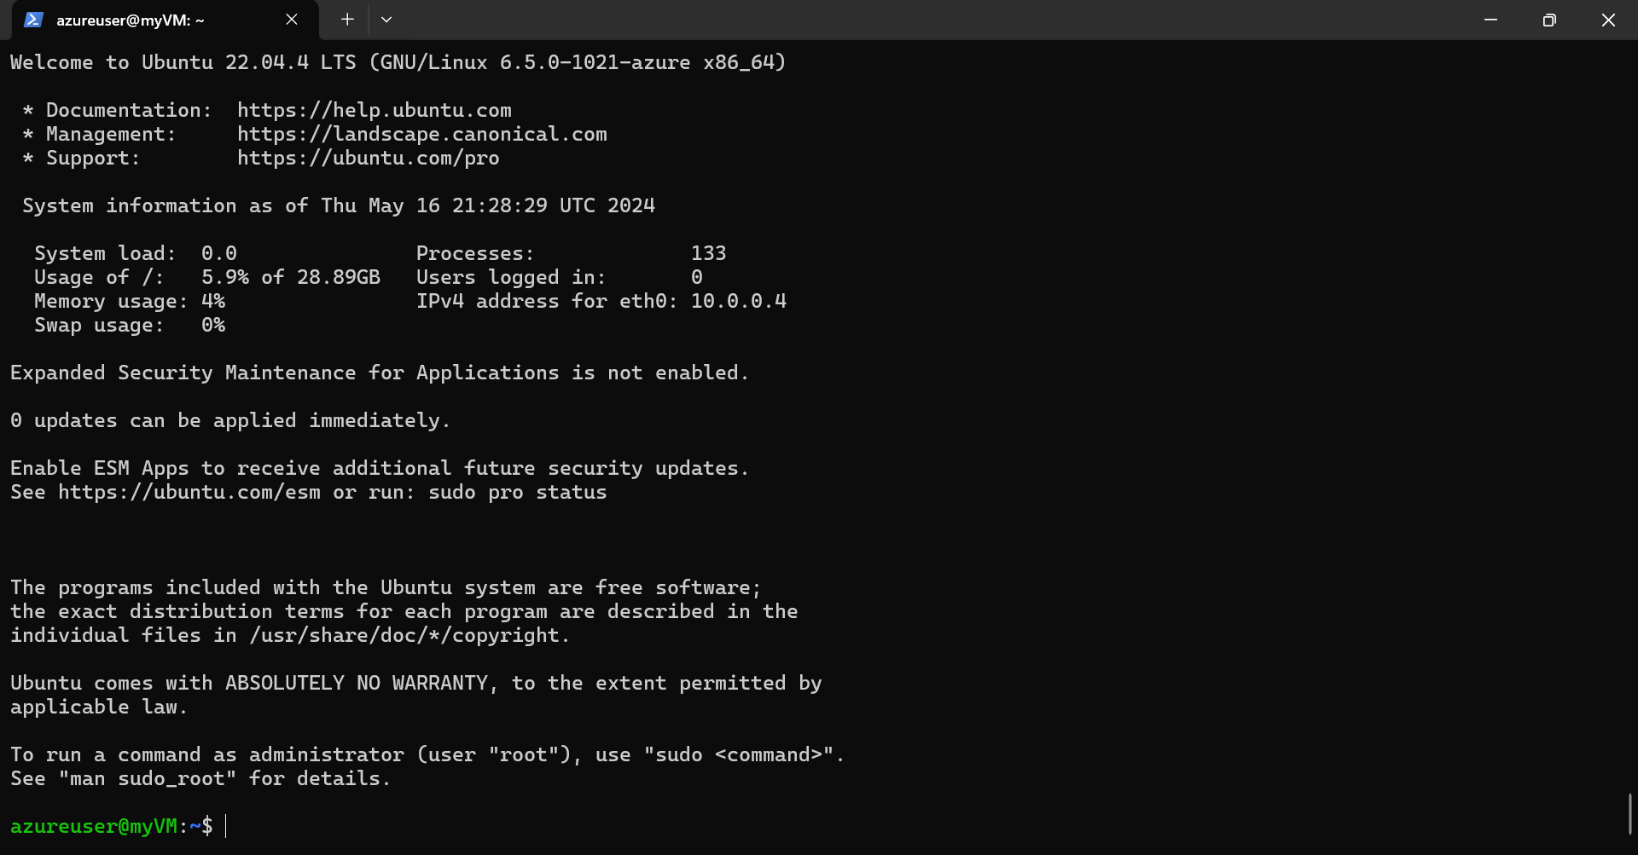

Task 1.3: Install a light Desktop environment and XRDP
- You have now logged in into your VM and next we will install a light desktop environment on the server. Use the following command to install desktop environment
sudo apt-get update
sudo DEBIAN_FRONTEND=noninteractive apt-get -y install xfce4
sudo apt install xfce4-session
- Now configure remote desktop server
sudo apt-get -y install xrdp
sudo systemctl enable xrdp
- The xrdp session uses a certificate key file “/etc/ssl/private/ssl-cert-snakeoil.key ( https://tecadmin.net/how-to-install-xrdp-on-ubuntu-22-04). So, add the xrdp user to the “ssl-cert” group with the following command:
sudo usermod -a -G ssl-cert xrdp
- Now restart the XRDP server:
sudo systemctl restart xrdp
- Next set a password for the azureuser and note it down for later use:
sudo passwd azureuser (I am setting MyPa55word as password)
- Exit from the VM. In command line type:
exit

Task 1.4: Login into your VM desktop environment
- You have exited from the command line ssh session. Now open the remote desktop application in your local machine and connect to the VM with XRDP.
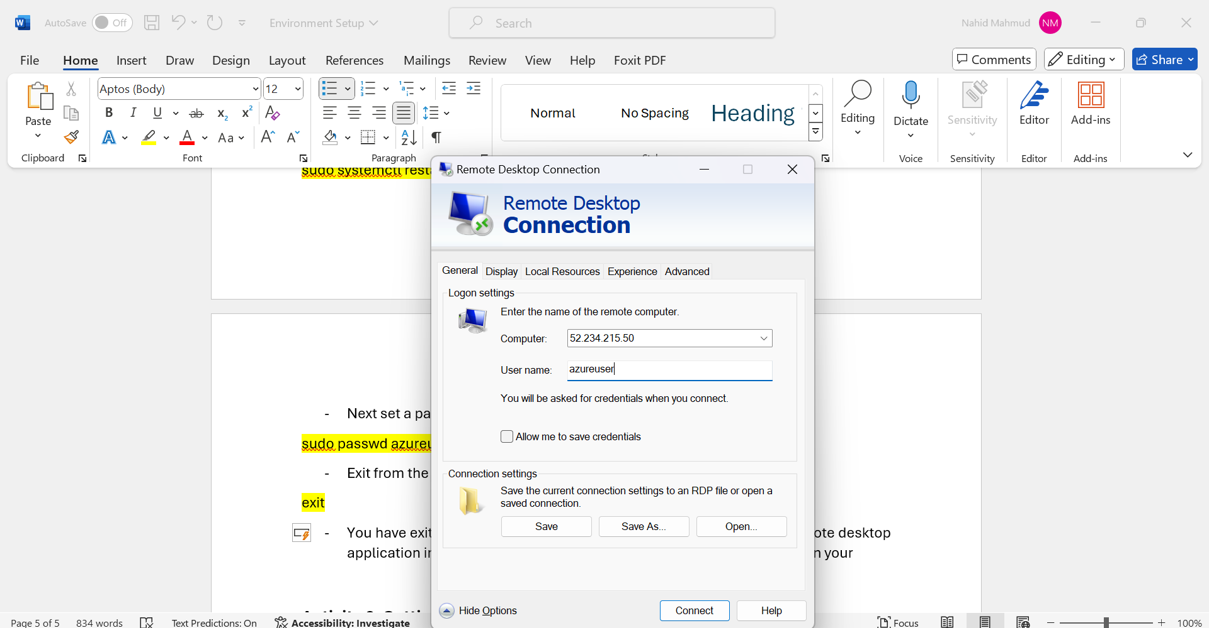

- For connection, use the IP address of your VM as Computer name and “azureuser” as User name as shown in the above image.
- If prompted for confirmation, select yes, and proceed. You should next see a screen for XRDP session in your VM as the following image.
- Enter “azureuser” as user and the password you set in the previous step. Keep Xorg selected as the default session manager.
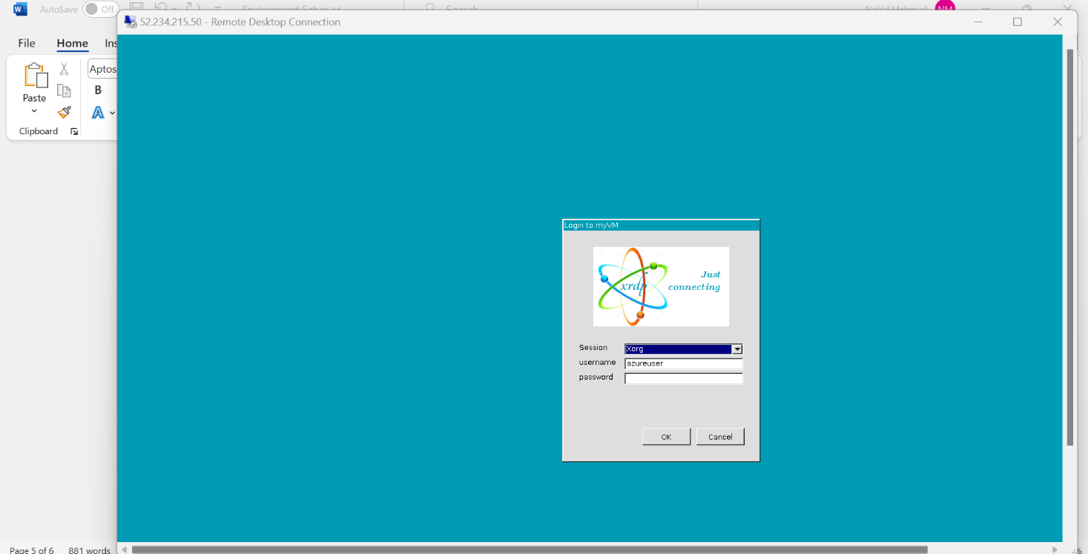

Task 1.5: Install google chrome on your VM
- Next open a terminal inside your RDP session and install google chrome as shown in the image below. Use the following commands:
sudo wget https://dl.google.com/linux/direct/google-chrome-stable_current_amd64.deb
sudo apt install ./google-chrome-stable_current_amd64.deb
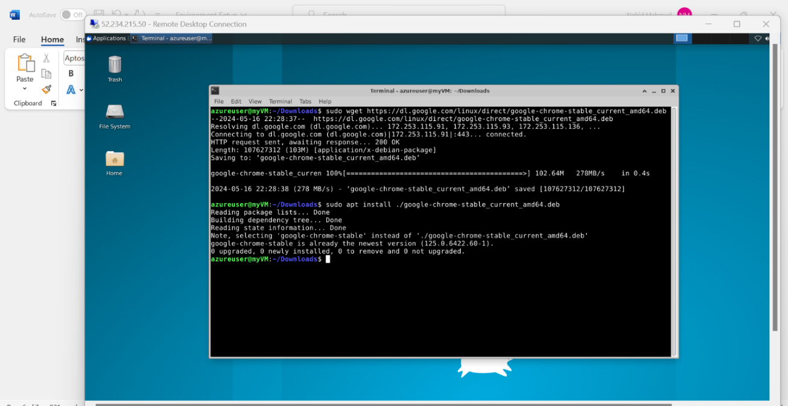

- This should install chrome on your VM and you can launch it from the application finder:
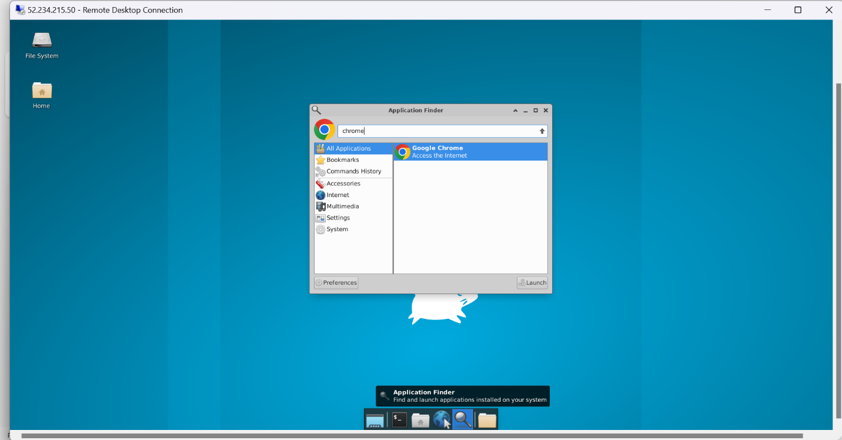

Activity 2: Setting up a Single Node Hadoop Cluster

Task 2.1: Install Java and configure profile on Ubuntu VM
- Hadoop compiles in Java 8 and has limited support for java 11. So, we will install openjdk-8-jdk on our Ubuntu VM. For that, first login into your VM with ssh:
ssh azureuser@20.232.160.204 (use the IP address of your VM)
- Now install Java:
sudo apt install openjdk-8-jdk
- Verify the Java version and location:
java -version
whereis java
readlink -f /usr/bin/java | sed "s:bin/java::"
- We will install Hadoop in /usr/local/hadoop directory. So, open the “.profile” file with “nano” editor:

sudo apt update
sudo apt install nano
nano .profile
- Now append the following lines in the .profile file:
export JAVA_HOME="/usr/lib/jvm/java-8-openjdk-amd64"
export HADOOP_HOME="/usr/local/hadoop"
- Press Ctrl+S to save the changes and Ctrl+X to exit
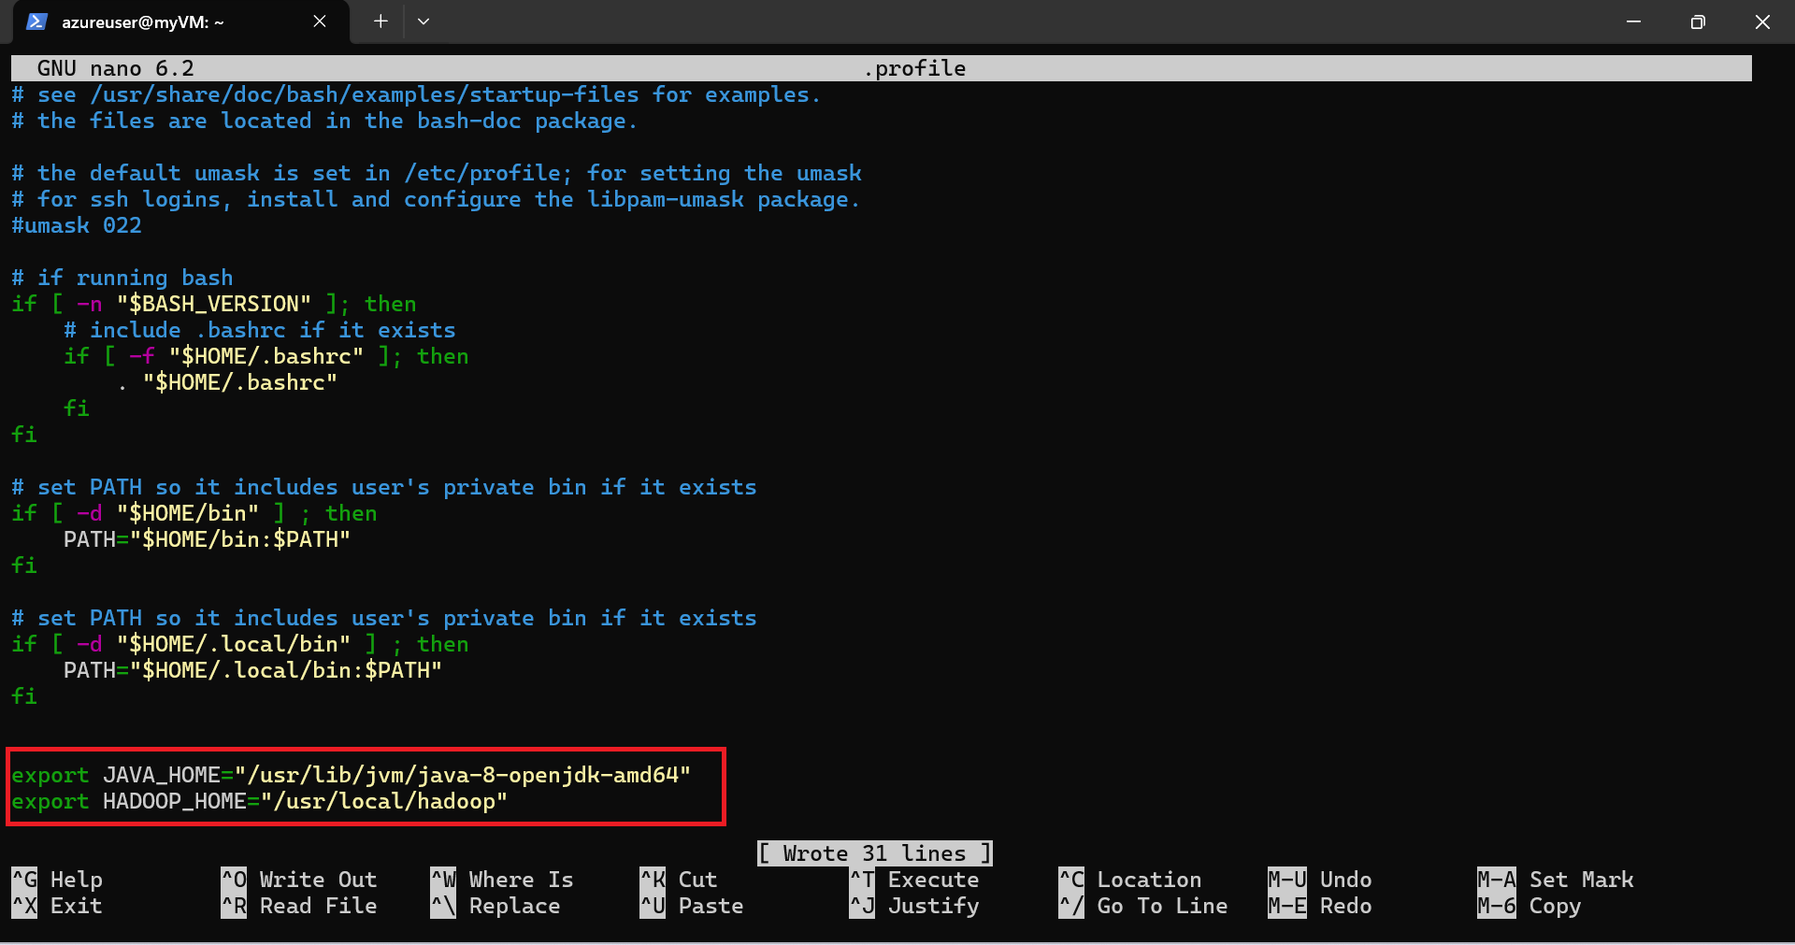

- Reload the profile and confirm the variables have been set correctly:
source .profile
echo $JAVA_HOME
echo $HADOOP_HOME

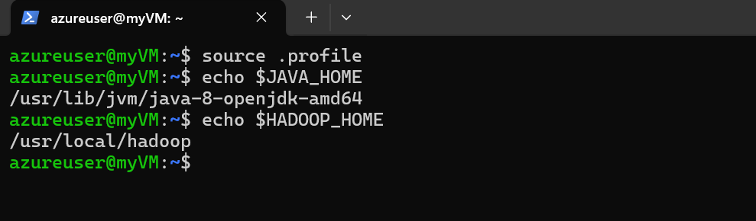

Task 2.2: Install Hadoop
- Download Hadoop:
wget https://archive.apache.org/dist/hadoop/common/hadoop-3.3.6/hadoop-3.3.6.tar.gz
- Extract the compressed files and move them to HADOOP_HOME location you set in the previous step:
tar -xzvf hadoop-3.3.6.tar.gz
sudo mv hadoop-3.3.6 "$HADOOP_HOME"
- Append the Hadoop binary executable file location to your profile:
echo "export PATH=\"\$PATH:\$HADOOP_HOME/bin\"" >> $HOME/.profile
- Verify HADOOP_HOME/bin IN PATH and press Ctrl+x to exit
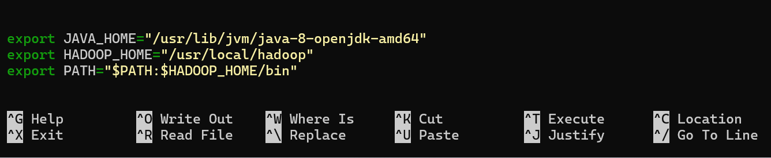
- Reload your profile:
source .profile
- Now, test if Hadoop installed and available. Run the following command. If Hadoop is running, then you can see hadoop commands:
- 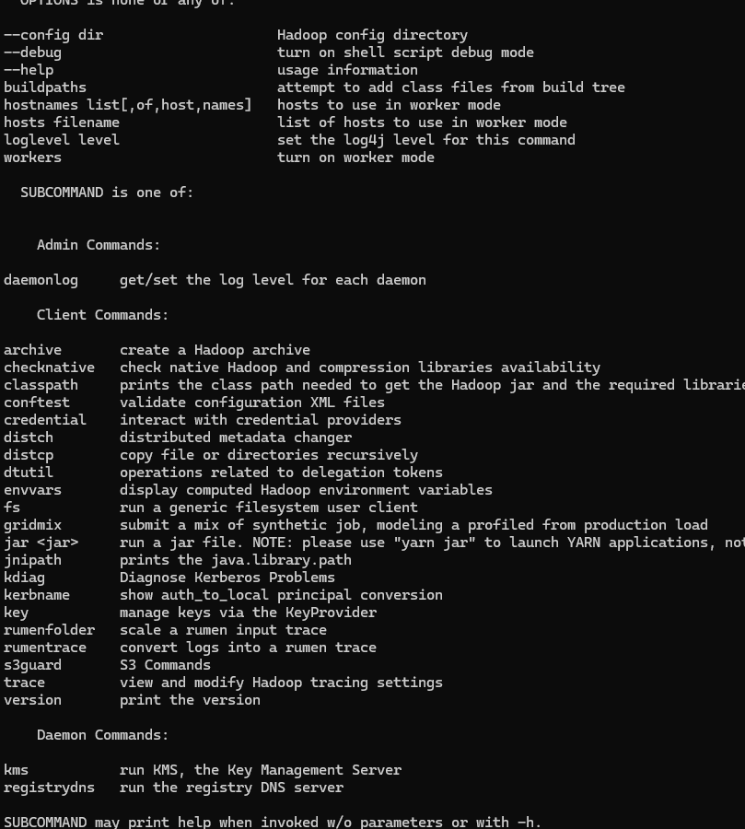
hadoop

Task 2.3: Configure Hadoop
- Edit the core-site.xml file:
sudo nano "$HADOOP_HOME/etc/hadoop/core-site.xml"
- Append the following contents inside the configuration tag:

<property>
<name>fs.defaultFS</name>
<value>hdfs://localhost:9000</value>
</property>
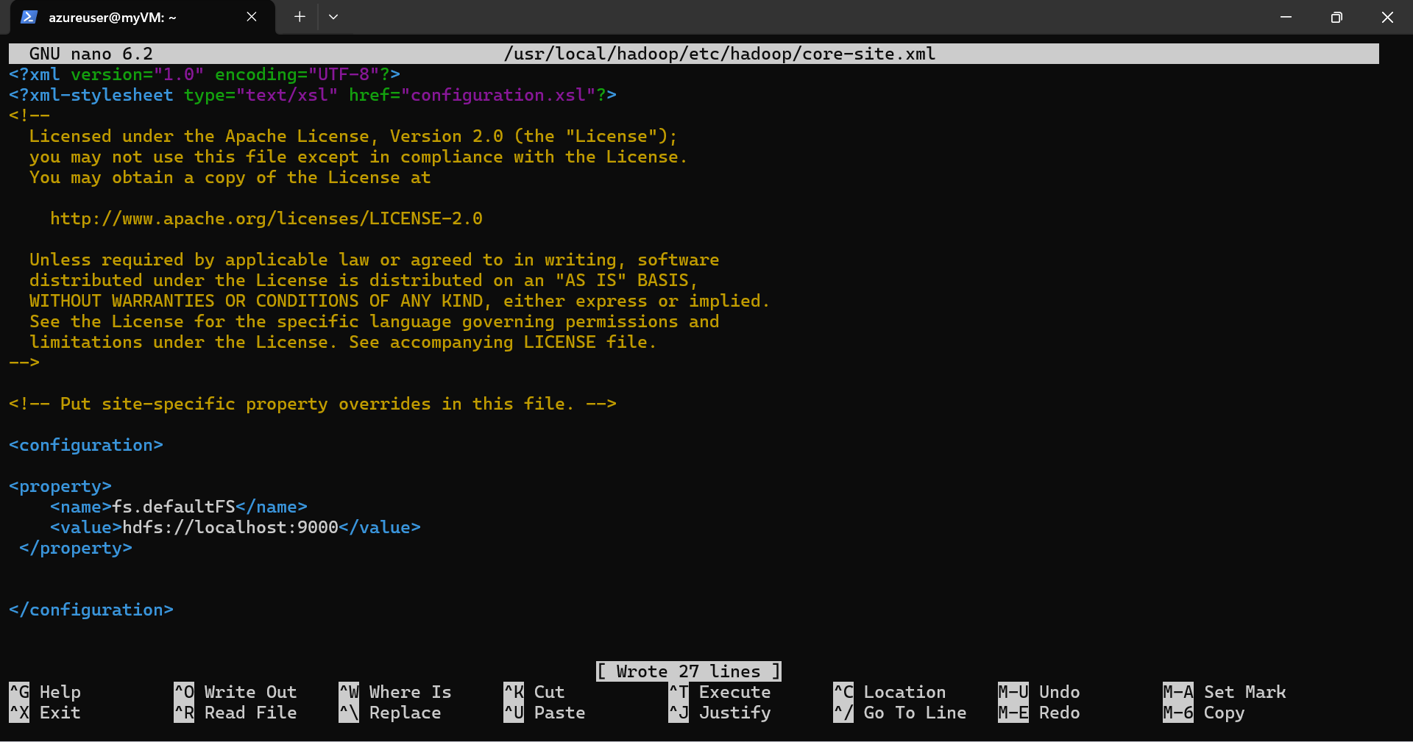
- Now press Ctrl+S to save and Ctrl+X to exit
- Next, Edit the hdfs-site.xml file:
sudo nano "$HADOOP_HOME/etc/hadoop/hdfs-site.xml"
- Append the following contents inside the configuration tag:

<property>
<name>dfs.replication</name>
<value>1</value>
</property>
<property>
<name>dfs.webhdfs.enabled</name>
<value>true</value>
</property>
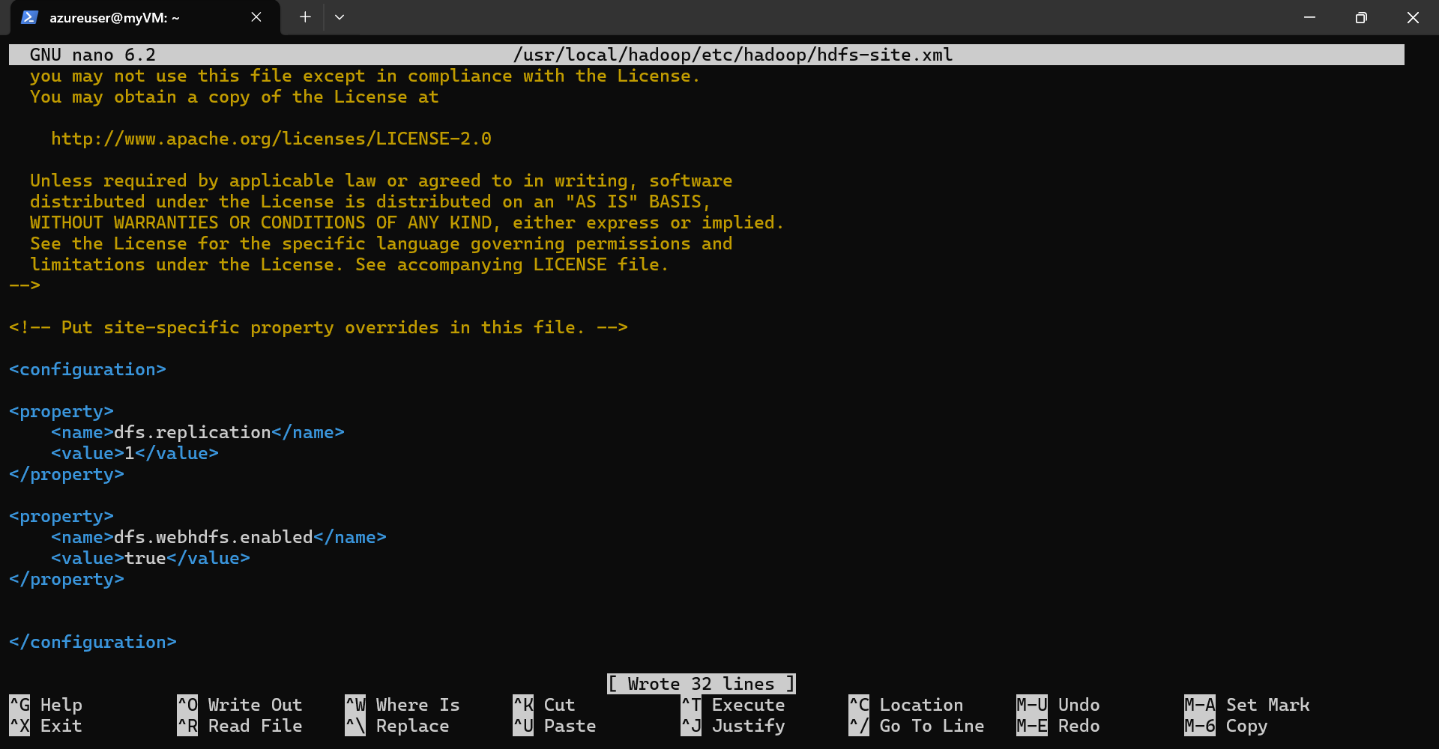
- Now press Ctrl+S to save and Ctrl+X to exit
- Hadoop uses ssh to connect to different services. So we need to setup ssh access for localhost. Type the following command and don’t use any passphrase:
ssh-keygen
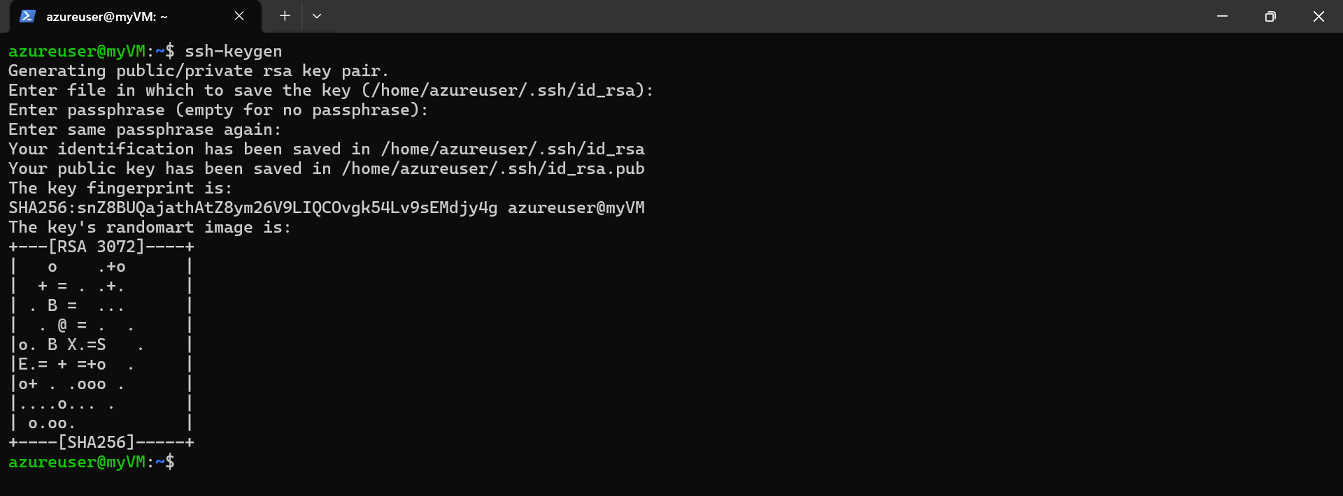
- Next, add the generated key to the authorized keys:
cat $HOME/.ssh/id_rsa.pub >> $HOME/.ssh/authorized_keys
- Give appropriate permissions:
chmod 600 $HOME/.ssh/authorized_keys
- Test ssh login into localhost and exit:
ssh localhost
exit
- Next, set appropriate permissions:
sudo chown -R "$(whoami):" "$HADOOP_HOME"
- Format HDFS namenode:
hdfs namenode -format
- Add path variable to .profile file:
echo "export PATH=\"\$PATH:\$HADOOP_HOME/sbin\"" >> $HOME/.profile
- Reload the profile:
source $HOME/.profile
- Append JAVA_HOME variable to hadoop-env.sh file:
echo "export JAVA_HOME=\"/usr/lib/jvm/java-8-openjdk-amd64\"" >> "$HADOOP_HOME/etc/hadoop/hadoop-env.sh"
- Open the file with “nano” editor and verify that the path has been added at the end:
nano "$HADOOP_HOME/etc/hadoop/hadoop-env.sh"
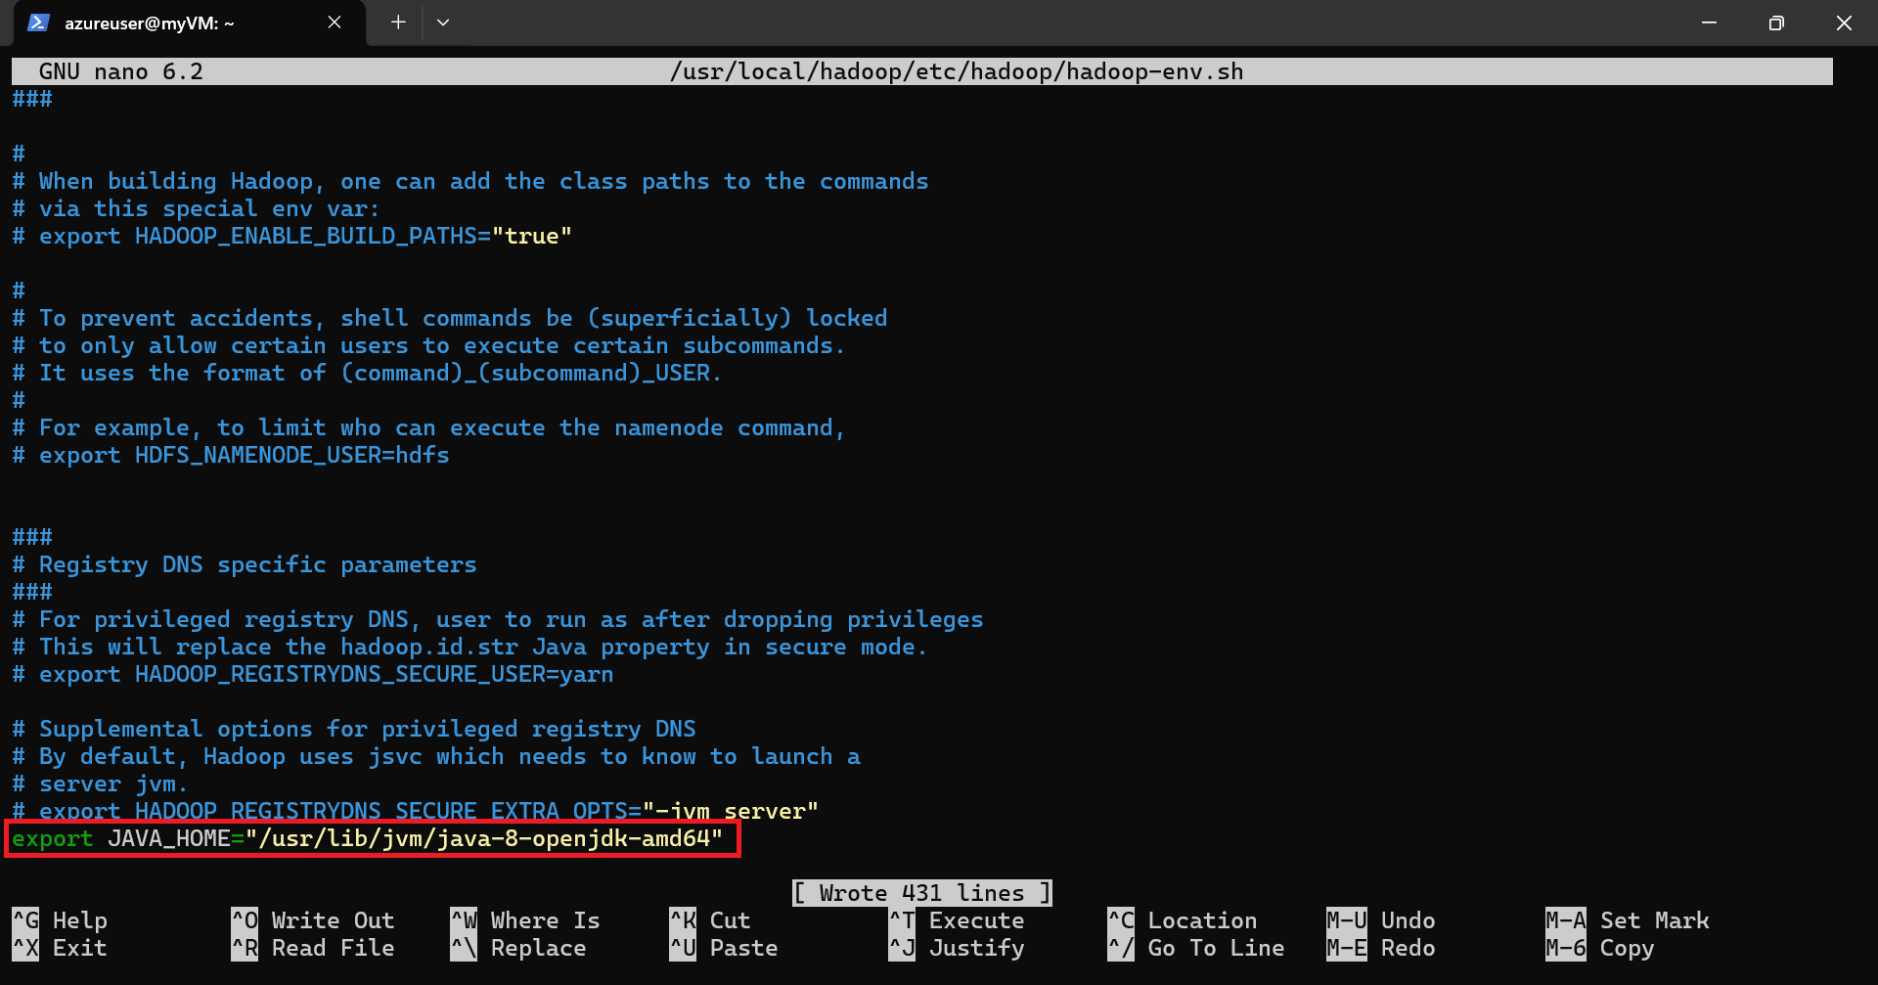
- Next, start the deamon processes:
start-dfs.sh
start-yarn.sh
- Verify the running java processes:
jps
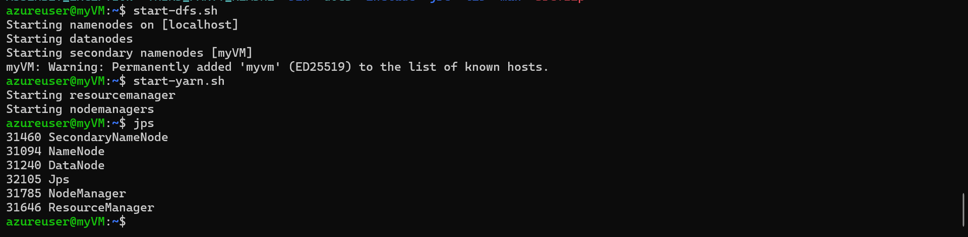
** following services should be running
NodeManager
NameNode
Jps
SecondaryNameNode
ResourceManager
DataNode
- We also need to verify that Hadoop GUI is accessible. We have to check that from the desktop environment. Let us connect to the VM from RDP (remote desktop) session. Like before, open the RDP application in your local machine:


- Next open the chrome browser on your VM and verify that the following links are available:
Resource Manager -->http://localhost:8088
Hadoop GUI -->http://localhost:9870
Hadoop FileSystem -->http://localhost:9870/explorer.html#/

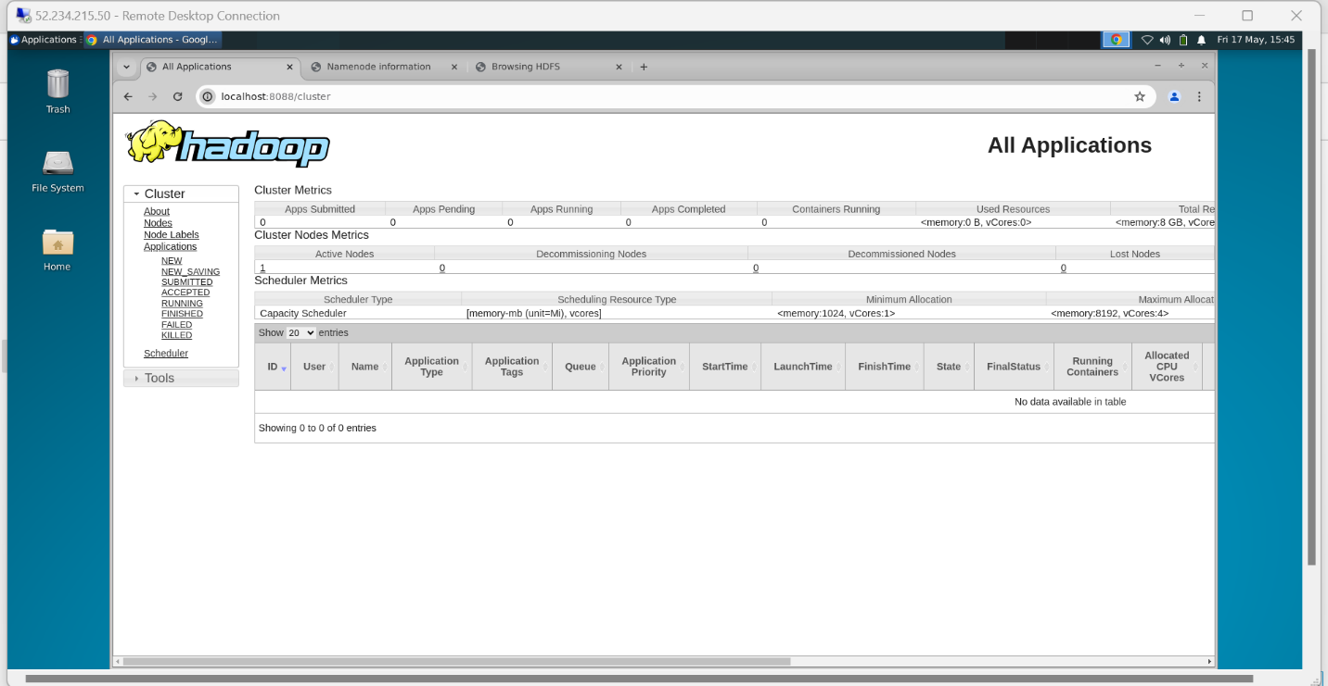
- Hadoop is now running on your VM. Next, we will proceed with Hive installation.

Task 2.6: Upload Sample data (1.Create sub folders in ubuntu)

SSH to ubunto
ssh azureuser@20.232.160.204
now run following commands in a batch by putting them in a .sh file and then execute
first type

nano dataprep.sh
you will be presented with a nano editor, copy and paste following to the editor

mkdir data
cd data

mkdir adventureworks
mkdir AdventureWorksData
mkdir adventureworksv2
mkdir airflow
mkdir csvfiles
mkdir data
mkdir driverdata
mkdir inclassassignment
mkdir json
mkdir mysqlscript
mkdir salesView
mkdir snowflakes
mkdir tripdata
exit
ctrl+s and ctrl+x (save and exit)
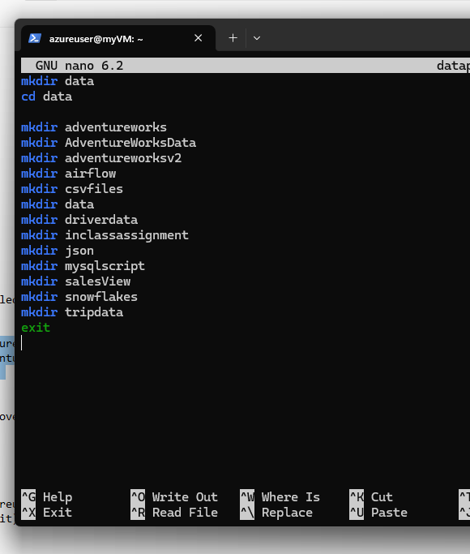
now type following command to execute the batch file
sh dataprep.sh
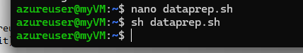
now all the subfolders are created.

Task 2.7: Upload Sample data (2. Copy Sample data to ubuntu subfolders)
Now, go to you personal machine (not ubuntu) , your personal notebook and navigate to the folder where you downloaded/unziped the sample data
dir
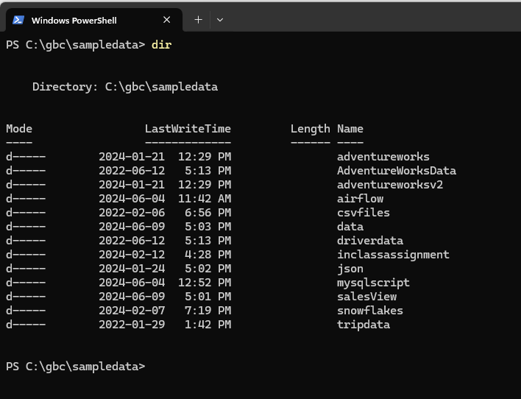
**you should see all the folders
cd sampledata

Copy and paste following and execute (replace with your own IP Address)
scp adventureworks\*.* azureuser@20.232.160.204:~/data/adventureworks
scp AdventureWorksData\*.* azureuser@20.232.160.204:~/data/AdventureWorksData
scp adventureworksv2\*.* azureuser@20.232.160.204:~/data/adventureworksv2
scp airflow\*.* azureuser@20.232.160.204:~/data/airflow
scp csvfiles\*.* azureuser@20.232.160.204:~/data/csvfiles
scp data\*.* azureuser@20.232.160.204:~/data/data
scp driverdata\*.* azureuser@20.232.160.204:~/data/driverdata
scp inclassassignment\*.* azureuser@20.232.160.204:~/data/inclassassignment
scp json\*.* azureuser@20.232.160.204:~/data/json
scp mysqlscript\*.* azureuser@20.232.160.204:~/data/mysqlscript
scp salesView\*.* azureuser@20.232.160.204:~/data/salesView
scp snowflakes\*.* azureuser@20.232.160.204:~/data/snowflakes
scp tripdata\*.* azureuser@20.232.160.204:~/data/tripdata

Task 2.8: Upload Sample data (3. Upload data to hadoop)
Now since you have copied all sample data to ubuntu, now its time to upload data to Hadoop from ubuntu
Again, type nano command to run script in batch as opposed to run them one by one
ssh azureuser@20.232.160.204
nano datacopy.sh
copy and paste following and Ctrl+s and Ctrl+x
cd data

hadoop fs -mkdir /user
hadoop fs -mkdir /user/input

hadoop fs -mkdir /user/input/adventureworks
hadoop fs -mkdir /user/input/AdventureWorksData
hadoop fs -mkdir /user/input/adventureworksv2
hadoop fs -mkdir /user/input/airflow
hadoop fs -mkdir /user/input/csvfiles
hadoop fs -mkdir /user/input/data
hadoop fs -mkdir /user/input/driverdata
hadoop fs -mkdir /user/input/inclassassignment
hadoop fs -mkdir /user/input/json
hadoop fs -mkdir /user/input/mysqlscript
hadoop fs -mkdir /user/input/salesView
hadoop fs -mkdir /user/input/snowflakes
hadoop fs -mkdir /user/input/tripdata

cd adventureworks
hadoop fs -put * /user/input/adventureworks
cd ..

cd AdventureWorksData
hadoop fs -put * /user/input/AdventureWorksData
cd ..

cd adventureworksv2
hadoop fs -put * /user/input/adventureworksv2
cd ..

cd airflow
hadoop fs -put * /user/input/airflow
cd ..

cd csvfiles
hadoop fs -put * /user/input/csvfiles
cd ..

cd data
hadoop fs -put * /user/input/data
cd ..

cd driverdata
hadoop fs -put * /user/input/driverdata
cd ..

cd inclassassignment
hadoop fs -put * /user/input/inclassassignment
cd ..

cd json
hadoop fs -put * /user/input/json
cd ..

cd mysqlscript
hadoop fs -put * /user/input/mysqlscript
cd ..

cd salesView
hadoop fs -put * /user/input/salesView
cd ..

cd snowflakes
hadoop fs -put * /user/input/snowflakes
cd ..

cd tripdata
hadoop fs -put * /user/input/tripdata
cd ..

hadoop fs -ls /user/input/adventureworks
hadoop fs -ls /user/input/AdventureWorksData
hadoop fs -ls /user/input/adventureworksv2
hadoop fs -ls /user/input/airflow
hadoop fs -ls /user/input/csvfiles
hadoop fs -ls /user/input/data
hadoop fs -ls /user/input/driverdata
hadoop fs -ls /user/input/inclassassignment
hadoop fs -ls /user/input/json
hadoop fs -ls /user/input/mysqlscript
hadoop fs -ls /user/input/salesView
hadoop fs -ls /user/input/snowflakes
hadoop fs -ls /user/input/tripdata

now execute the batchfile
sh datacopy.sh
**all data copied

Activity 3: Setting up a Hive

Task 3.1: Install and Configure Hive
- Hadoop is a framework to store big data in a distributed file system (HDFS), while Hive provides an SQL Based tool to query this data. Hive queries all the data using HQL (Hive Query Language).
- First, let us download Hive in our VM. If you have already logged in your VM with ssh then type the following command. Else login and then type the following command in your terminal:
wget https://dlcdn.apache.org/hive/hive-3.1.3/apache-hive-3.1.3-bin.tar.gz
- Next, uncompress the downloaded tar file:
tar -xzf apache-hive-3.1.3-bin.tar.gz
- Move the files to preferred installation location (/usr/local/hive):
sudo mv apache-hive-3.1.3-bin /usr/local/hive
- Open the “.bashrc” file with nano editor:
nano $HOME/.bashrc
- Add the following lines at the end of the file:
#Hadoop Path
export HADOOP_HOME=/usr/local/hadoop
export PATH=$PATH:$HADOOP_HOME/bin
export PATH=$PATH:$HADOOP_HOME/sbin
export HADOOP_MAPRED_HOME=${HADOOP_HOME}
export HADOOP_COMMON_HOME=${HADOOP_HOME}
export HADOOP_HDFS_HOME=${HADOOP_HOME}
export YARN_HOME=${HADOOP_HOME}

#Hive configurations
export HIVE_HOME=/usr/local/hive
export PATH=$PATH:$HIVE_HOME/bin
export HIVE_CONF_DIR=$HIVE_HOME/conf
export CLASSPATH=$CLASSPATH:$HADOOP_HOME/lib/*:.
export CLASSPATH=$CLASSPATH:$HIVE_HOME/lib/*:.
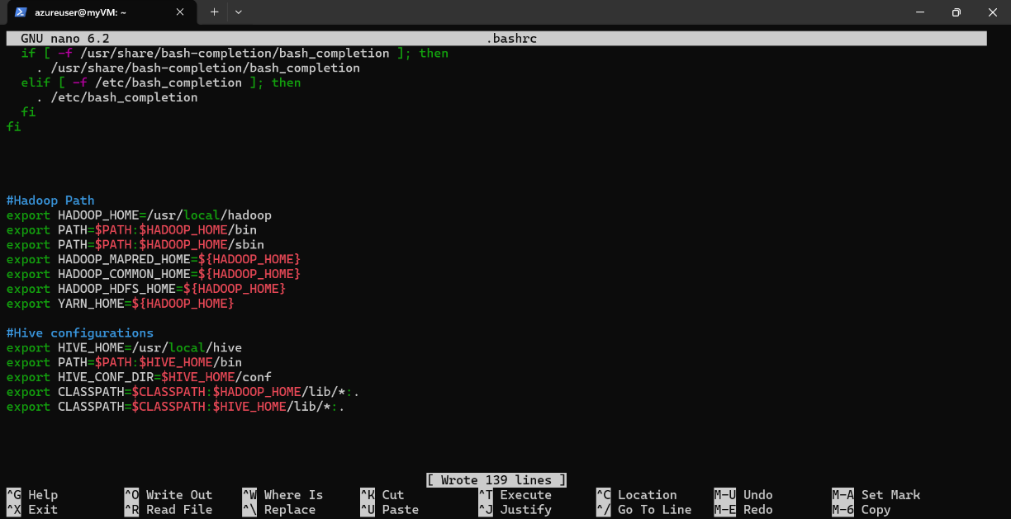
- After adding these environment variables, save with Ctrl+s and exit with Ctrl+x
- Reload the .bashrc file:
source .bashrc
- Next, create the Hive environment file:
cd $HIVE_HOME/conf
ls
sudo cp hive-env.sh.template hive-env.sh
- Open the file in nano editor and set the value for HADOOP_HOME:
sudo nano hive-env.sh
- Press Ctrl+w to search for HADOOP_HOME and, below it add the following line:
HADOOP_HOME=/usr/local/hadoop
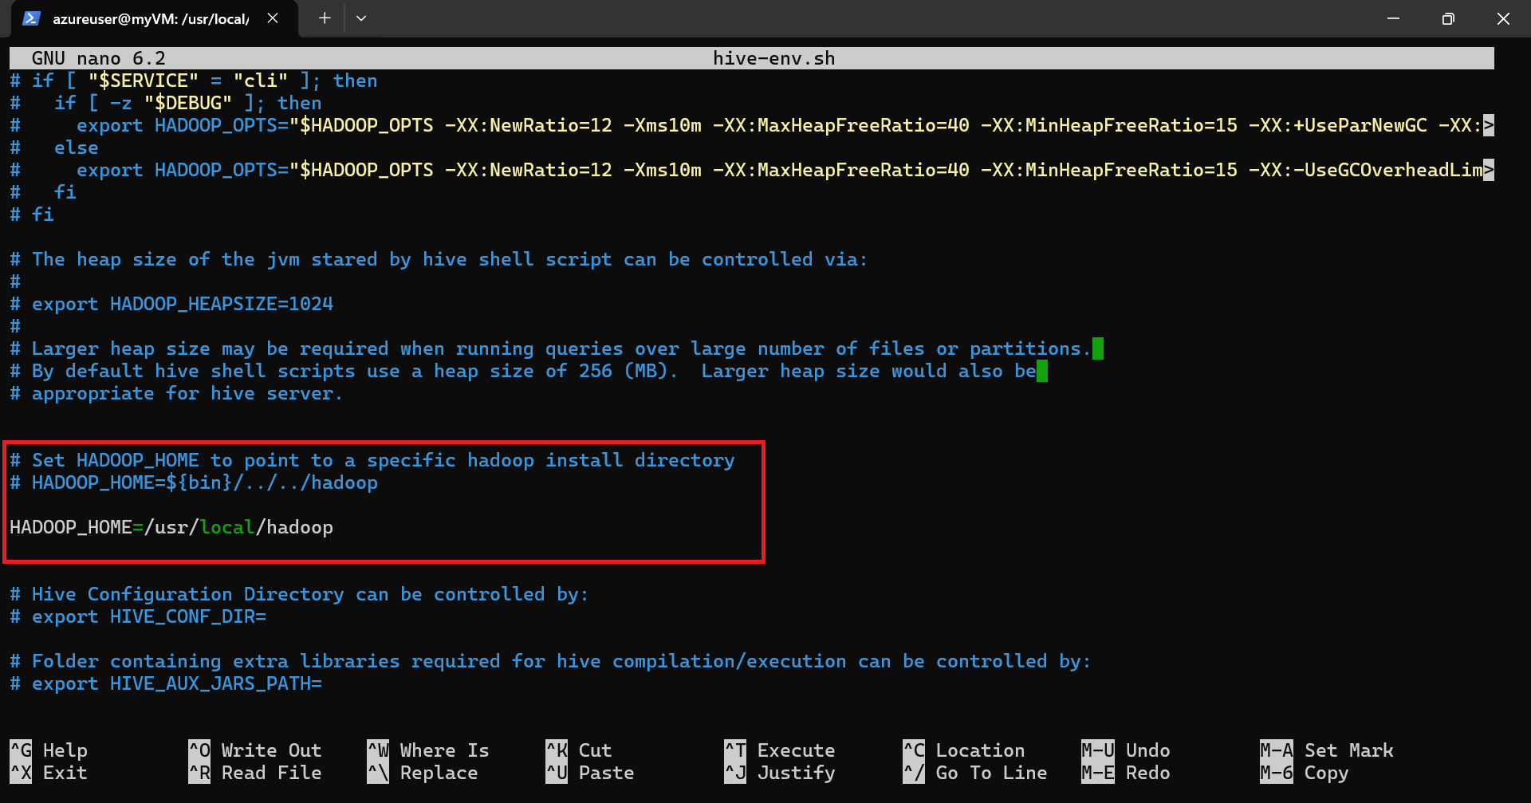

- Press Ctrl+s to save and Ctrl+x to exit
- Create the hive-site.xml file:
sudo cp hive-default.xml.template hive-site.xml
- Open the file in nano editor:
sudo nano hive-site.xml
- Append following lines inside the first configuration tag:
<property>
<name>system:java.io.tmpdir</name>
<value>/tmp/hive/java</value>
</property>
<property>
<name>system:user.name</name>
<value>${user.name}</value>
</property>
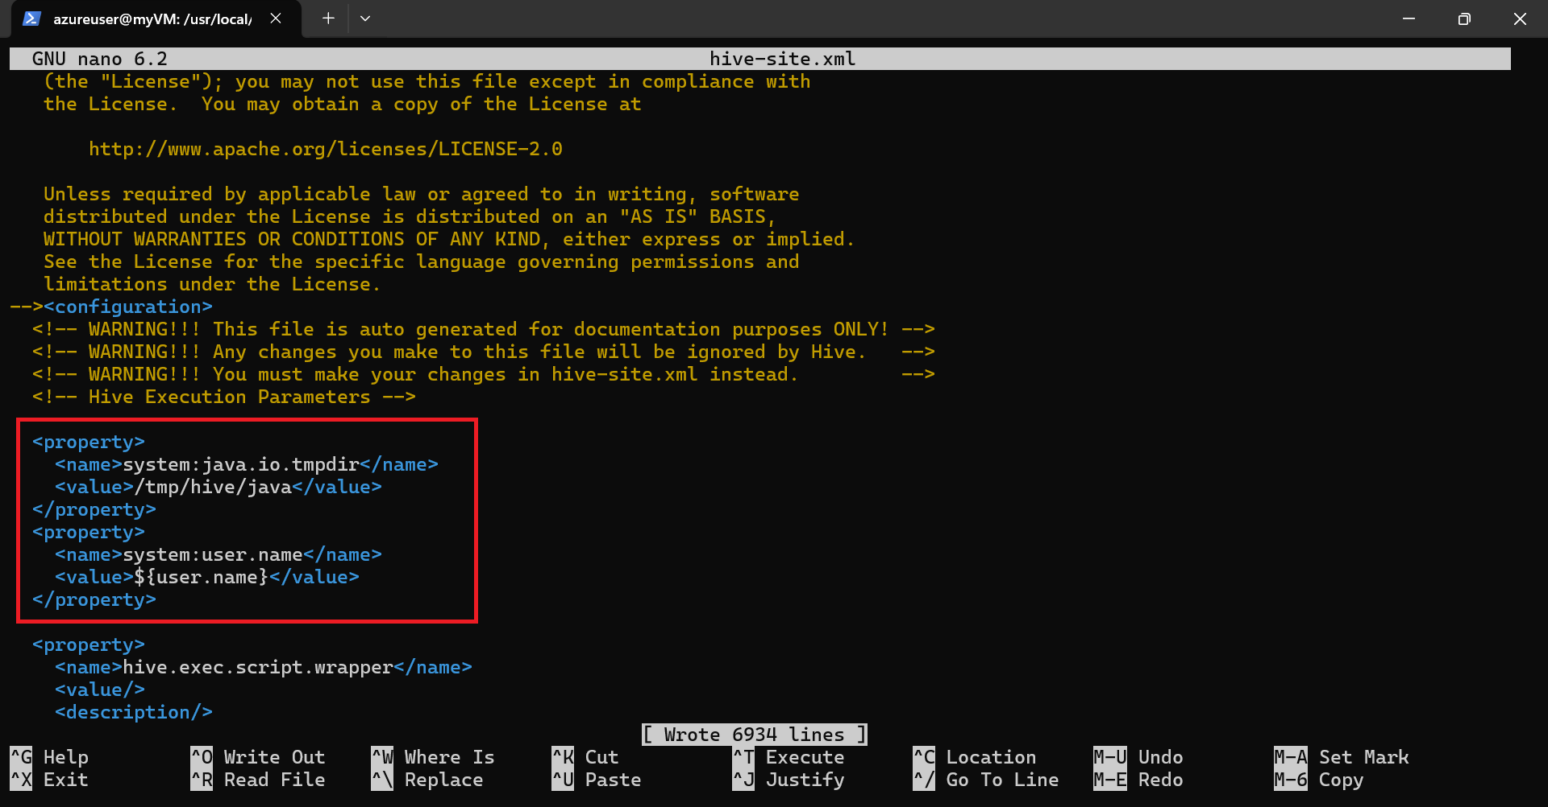

- Press Ctrl+s to save and Ctrl+x to exit
- Create a directory for Hive warehouse:
hadoop fs -mkdir -p /user/hive/warehouse
hadoop fs -chmod g+w /user/hive/warehouse
- Next we will initialize derby as hive metastore.
cd $HIVE_HOME/conf

- Remove the illegal character in hive-site.xml :
sudo nano hive-site.xml
- Press Ctrl+w and search for "Ensures commands with OVERWRITE" and remove the invalid characters between “for” and “transactional”
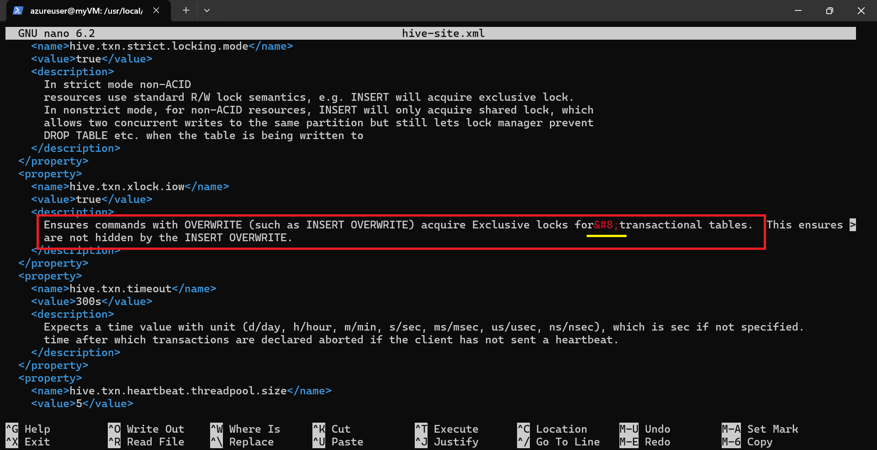

- Press Ctrl+s to save and Ctrl+x to exit
- Next, initialize the derby schema:
cd $HIVE_HOME
$HIVE_HOME/bin/schematool -dbType derby -initSchema
- Wait for the schemaTool prompt to complete. Now you should see metastore_db folder.
ls
$HIVE_HOME/bin/schematool -dbType derby -info
- Test derby as hive metastore:
hive
- You should see the hive prompt.
- show databases;
- Then type “exit;” to exit from the prompt:

exit;
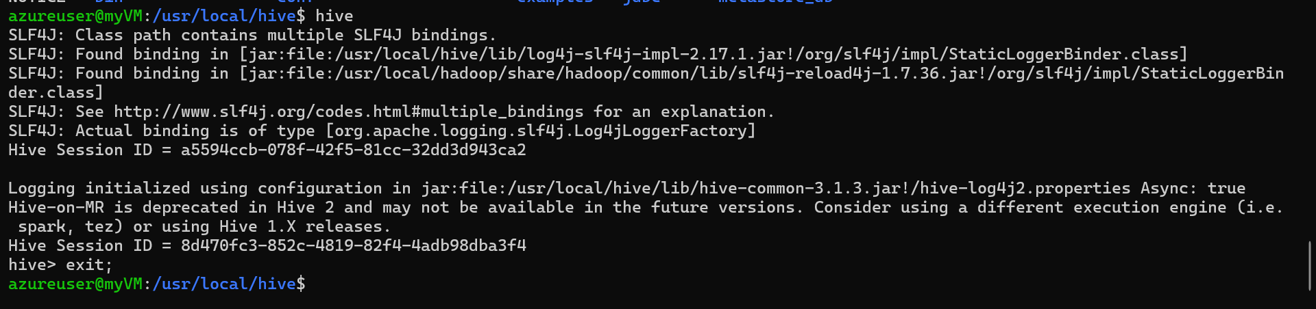

Task 3.2: Test Beeline
- The primary difference between Hive CLI and Beeline is how the clients connect to Hive. The Hive CLI, connects directly to HDFS and the Hive Metastore, and can be used only on a host with access to these services. Beeline can connect to HiveServer2 and requires access to only one.
- Now, let’s configure beeline:
cd $HIVE_HOME/conf
sudo nano hive-site.xml
- Search for “jdbc:derby” (Ctrl+w for search) and update the following by providing full path to metastore_db
databaseName=/usr/local/hive/metastore_db
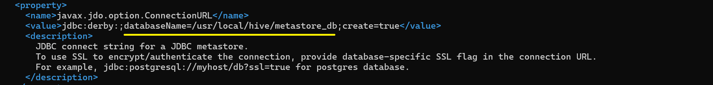
- Press Ctrl+s to save and Ctrl+x to exit
- Test beeline:
beeline -u jdbc:hive2://
- This will connect you to the beeline prompt. Now check the available databases and exit:
show databases;
!q
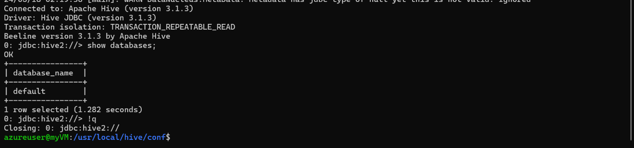

Task 3.3: Configure MySQL as metastore
- We have configured and tested Derby as hive metastore but the disadvantage with Derby is that it is an embedded database. And it supports only a single session at a time which leads to session lock and race conditions. It is not recommended to use it with other services (like Spark).
- So, we will install and configure MySQL.
Reference: https://www.digitalocean.com/community/tutorials/how-to-install-mysql-on-ubuntu-22-04
- First, Install MySQL server with the following command:
sudo apt-get install mysql-server
- Once the installation is completed, enter into the mysql shell:
sudo mysql
- Inside the mysql cmd set the password AzurePassword for the root user with the following query:
ALTER USER 'root'@'localhost' IDENTIFIED WITH mysql_native_password BY 'AzurePassword';
- Exit the mysql cmd by typing:
exit
- Next, install the MariaDB JDBC driver:
sudo apt install libmariadb-java
- After installing the driver create a symbolic link so that it is available to hive:
ln -s /usr/share/java/mariadb-java-client.jar $HIVE_HOME/lib/mariadb-java-client.jar
- Now, let’s configure MySQL for Hive:
cd $HIVE_HOME/conf
sudo nano hive-site.xml
- Search for <name>javax.jdo.option.ConnectionURL</name> (Ctrl+w for search) and update the property by putting the following string inside the value tag:
jdbc:mysql://localhost:3306/metastore?createDatabaseIfNotExist=true
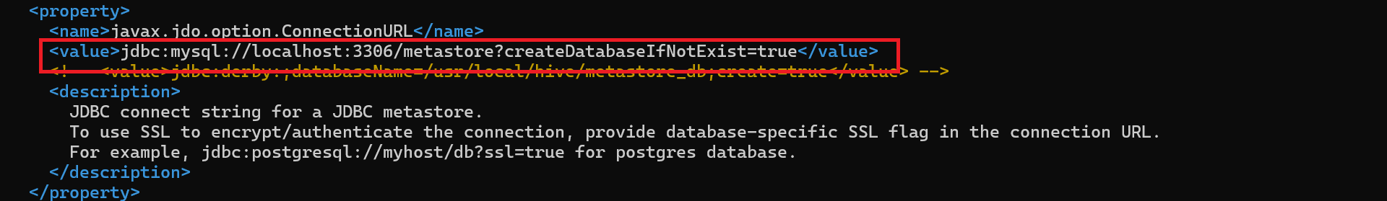
- Press Ctrl+s to save
- Similarly search for “javax.jdo.option.ConnectionDriverName” (Ctrl+w for search) and update the property by putting the following string inside the value tag:
org.mariadb.jdbc.Driver
- Press Ctrl+s to save
- Next search for “<name>javax.jdo.option.ConnectionUserName</name>” (Ctrl+w for search) and update the property by putting the following string inside the value tag:
root
- Press Ctrl+s to save
- Next search for “javax.jdo.option.ConnectionPassword” (Ctrl+w for search) and update the property by putting the following string inside the value tag:
AzurePassword
- Press Ctrl+s to save and Ctrl+x to exit.
- Now, initialize the metastore schema:
$HIVE_HOME/bin/schematool -dbType mysql -initSchema
$HIVE_HOME/bin/schematool -dbType mysql -info
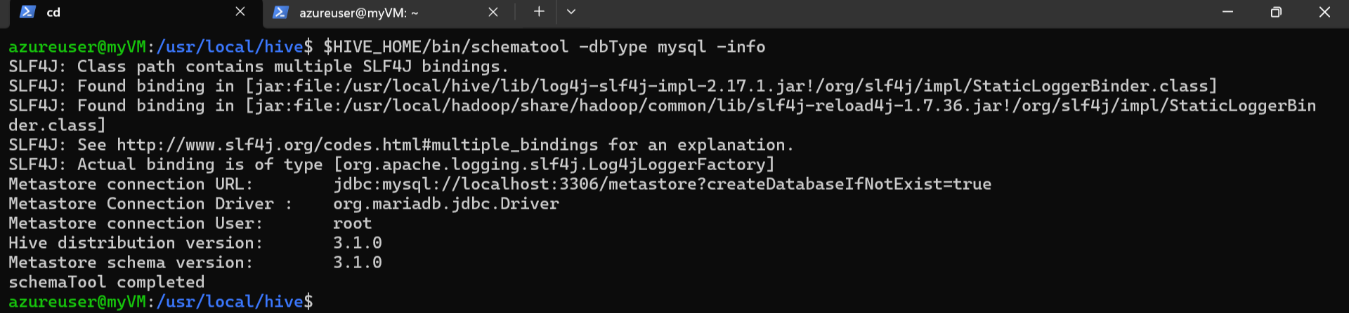
- Notice all the property values are set correctly.
- Now, login to your MySQL cmd with the following command:
mysql -u root -p
- Provide the password AzurePassword when prompted.
- Run the following query in MySQL cmd:
show databases;
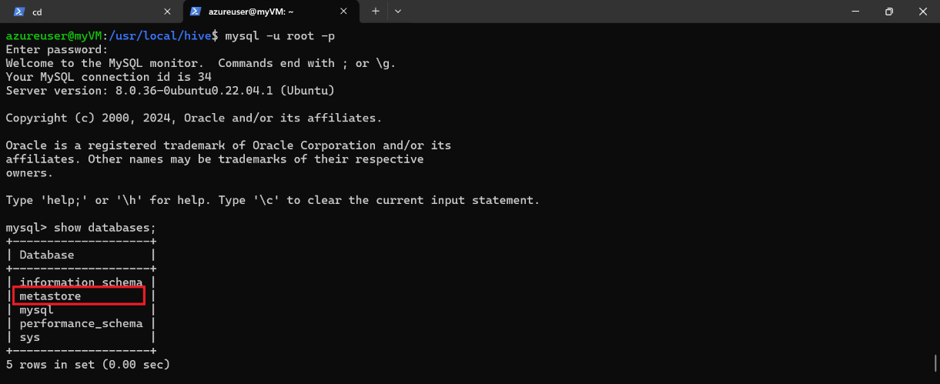
- Notice the metastore database is now created.
- Type exit to exit from the MySQL cmd.
- Next, run metastore as a service:
nohup hive --service metastore &
- Press Enter to proceed.
- Now let us install the net-tools package:
sudo apt -y install net-tools
- Next, check if the metastore service is running and listening on port 9083:
netstat -anp | grep 9083

Task 3.4: Run Hive as a service
- Next, we want to configure HiveServer2 to run as a service on port 10000, so that clients can communicate over http ports. Check the following link for reference:
https://sparkbyexamples.com/apache-hive/hive-start-hiveserver2-and-beeline/
- Start the HiveServer2 as a service with nohup. This will run HiveServer2 as a background service:
nohup hive --service hiveserver2 &
- Press Enter to continue.
- Next, check if the HiveServer2 service is running and listening on port 10000:
- Wait for a minute. This may take a minute to refresh
netstat -anp | grep 10000
jps
- The jps command shows that a hiveserver2 is running as RunJar:
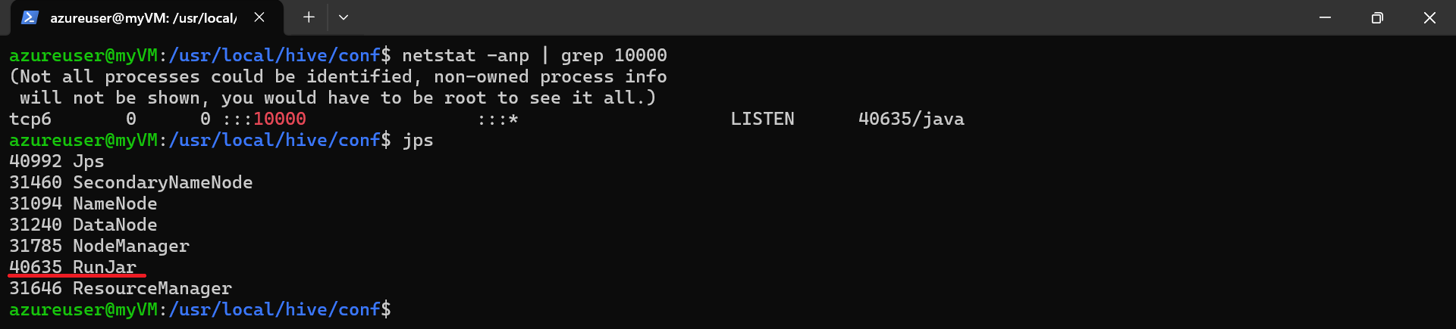
- Get the process id of RunJar and kill it to shut down the hiveserver. In my case, the id is 40635 as shown in the above image. Note the ID for your case.
sudo kill -9 40635 (replace 40635 with your process id ) (Kill all jobs if more then 1)
- Next, configure hiveserver2 so that beeline can connect:
cd $HIVE_HOME/conf/
sudo nano hive-site.xml
- Search for “hive.server2.enable.doAs” (Ctrl+w for search) and change the value from true to false:
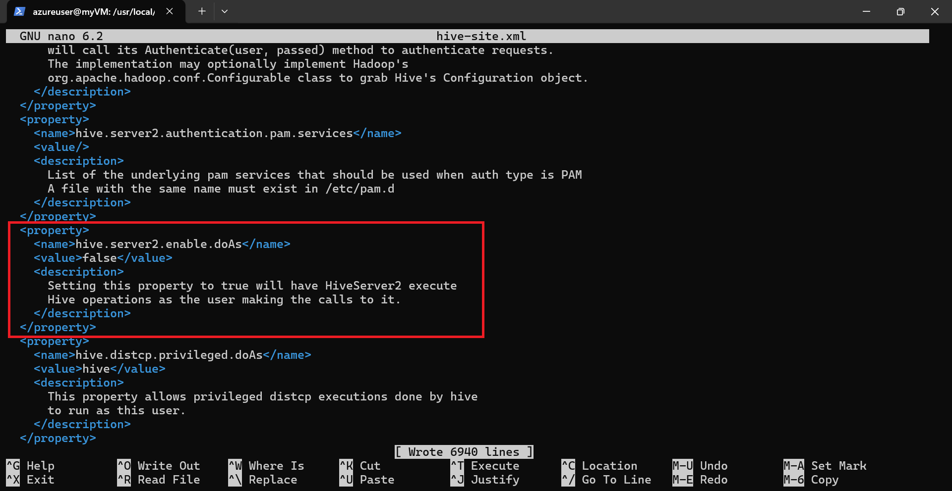
- Press Ctrl+s to save and Ctrl+x to exit
- Now start the hiveserver2 like before:
nohup hive --service hiveserver2 &
- Press Enter to proceed. Wait for a minute for the service to start then check:
netstat -anp | grep 10000
jps
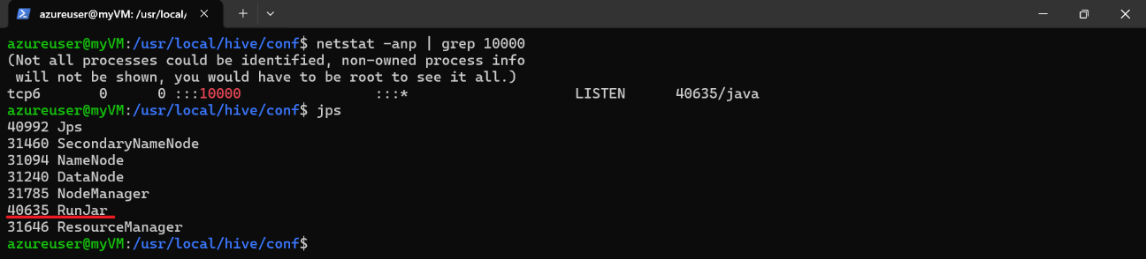
- Now, test if you can connect to the hiveserver2 with beeline:
beeline -u jdbc:hive2://localhost:10000
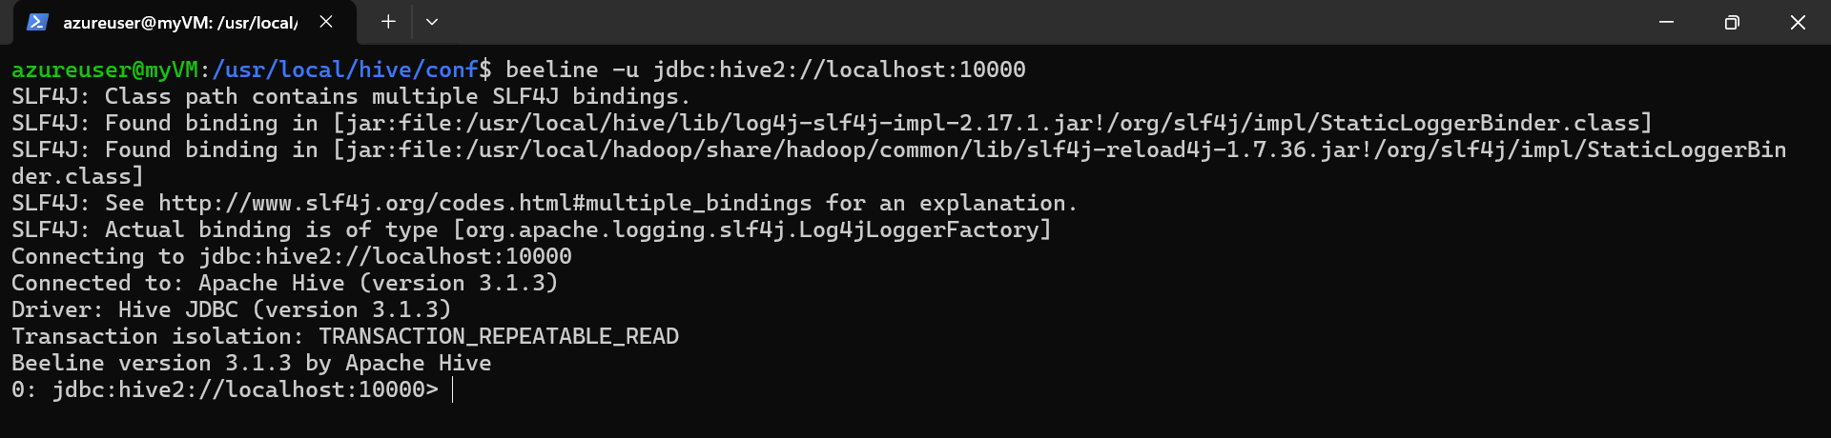
- Inside the beeline prompt, check the databases and then quit:
show databases;
create database testbigdata;
!q
- Now, connect to VM with remote desktop from your pc:
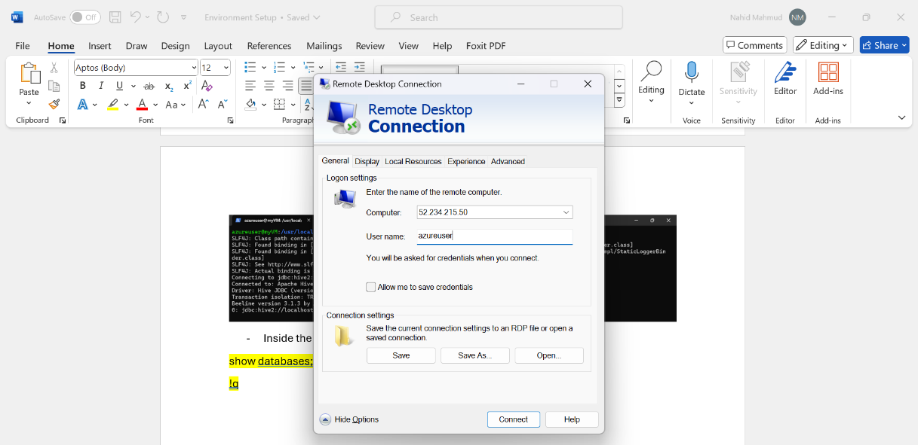

- Inside the VM desktop check if Hive Web UI is available at localhost:10002
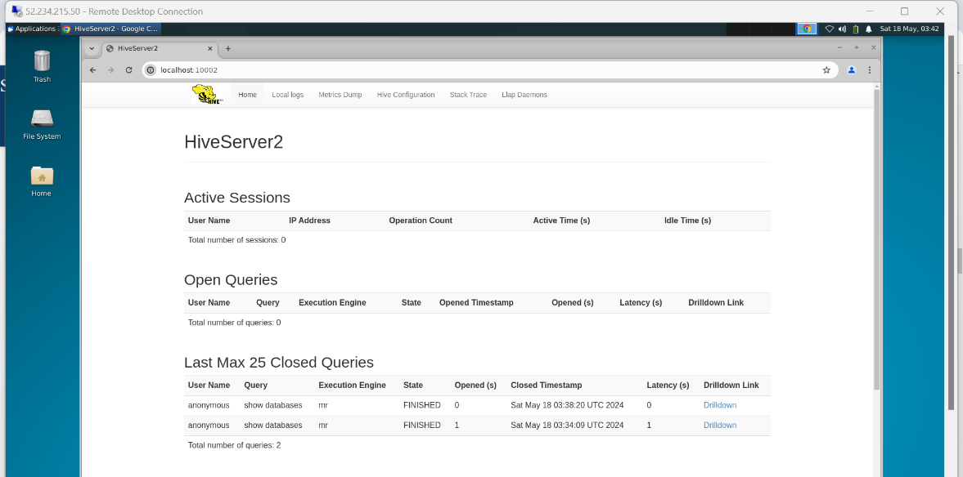

Task 3.5: Install DBeaver
- DBeaver provides a graphical user interface (GUI) for querying databases, as well as for managing databases and their objects.
- First let us add the DBeaver repository:

sudo apt-get install software-properties-common
sudo add-apt-repository ppa:serge-rider/dbeaver-ce
sudo apt update
- Install DBeaver:
sudo apt install dbeaver-ce
- Now DBeaver should be available in your VM. connect to VM with remote desktop from your pc:

- Inside the VM desktop from application finder search DBeaver and launch.
- Click on Application -> Development -> dbeaver-ce
- Click yes to create sample data.
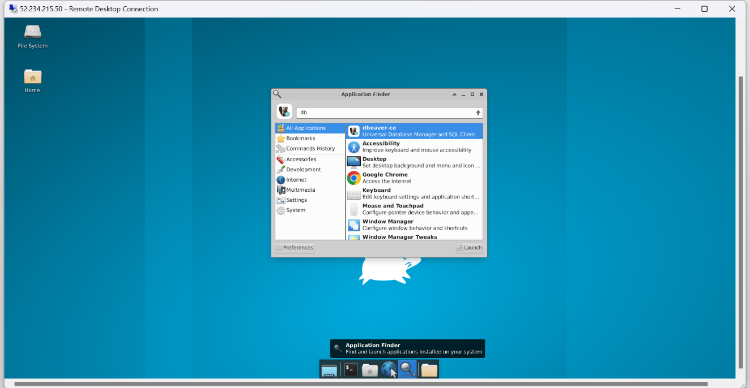
- Now connect to your hive database.
- Connect to MySQL
- Menu - > Database->New Database Connection ->MySQL
  - Host : localhost
  - Port : 3306
  - Username : root
  - Password : AzurePassword
- Rename connection to MySQL
- Expand the node, download the driver,
  - you will find metastore database

- Connect to Apache HIVE
- Menu - > Database->New Database Connection ->Apache Hive
  - Host : localhost
  - Port : 10000 (no username/password required)
Click next (you may need to click on download driver)
You will see testbigdata database that you created in previous step
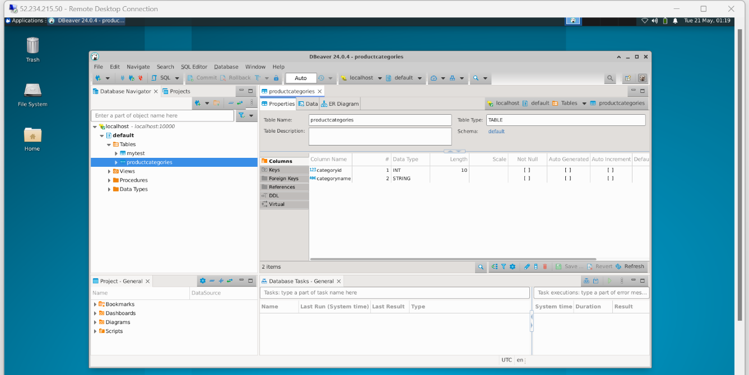

Task 3.6: append Sample Data to MySQL
ssh to terminal
mysql -u root -p
Enter password: ********
- Then, load the database by using the source command
source /home/azureuser/data/mysqlscript/nation.sql
source /home/azureuser/data/mysqlscript/myadventureworks.sql
use nation;
show tables;
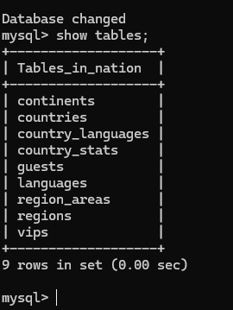
- Create users / passwords
CREATE USER 'alinizar'@localhost IDENTIFIED BY 'alinizarpwd';
SELECT User FROM mysql.user;
GRANT ALL PRIVILEGES ON nation.* TO 'alinizar'@localhost;
FLUSH PRIVILEGES;

use adventureworks
CREATE USER 'alinizar'@localhost IDENTIFIED BY 'alinizarpwd';
SELECT User FROM mysql.user;
GRANT ALL PRIVILEGES ON nation.* TO 'alinizar'@localhost;
FLUSH PRIVILEGES;

quit

Activity 4: Setting up Spark, PySpark and Jupyter Notebook

Task 4.1: Install Spark
- ssh login to your VM from PowerShell and go to user home directory with cd ~
- Check your current Hadoop version
hadoop version
- Now go to spark download site and find the appropriate version:
https://spark.apache.org/downloads.html
- Choose the Spark release for your Hadoop version and download spark:
wget https://dlcdn.apache.org/spark/spark-3.5.1/spark-3.5.1-bin-hadoop3.tgz
- Uncompress the file and move the folder to appropriate location:
tar -xzf spark-3.5.1-bin-hadoop3.tgz
sudo mv spark-3.5.1-bin-hadoop3 /usr/local/spark
- Open the .profile file with nano editor:
nano .profile
- Append the following lines at the end of the file:
# set spark settings
export SPARK_HOME="/usr/local/spark"
export PATH="$PATH:$SPARK_HOME/bin"
# end of spark settings

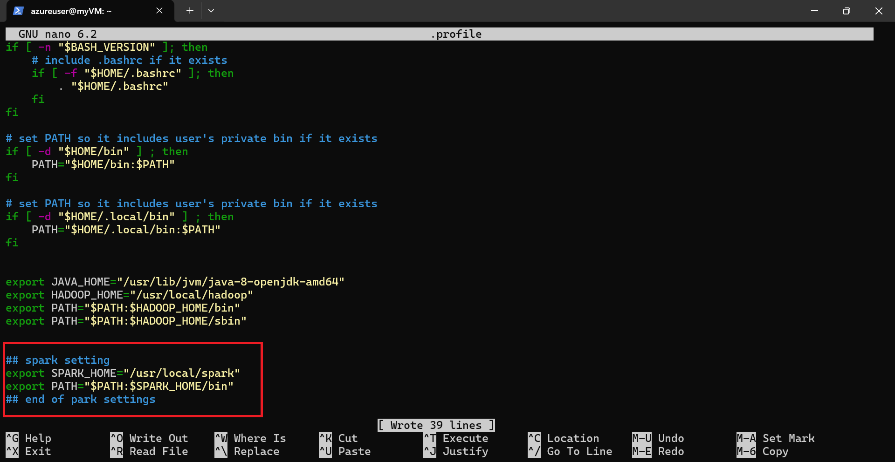
- Press Ctrl+s to save and Ctrl+x to exit
- Reload the .profile file
source .profile
- Confirm spark-shell is available by the following command:
spark-shell
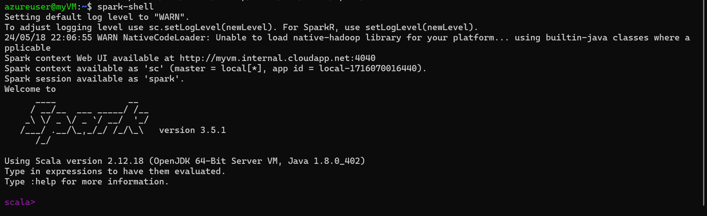
- Now, connect to VM with remote desktop from your pc:

- Inside the VM desktop check if Spark Web UI is available at localhost:4040(scala spark should be running on terminal)
- 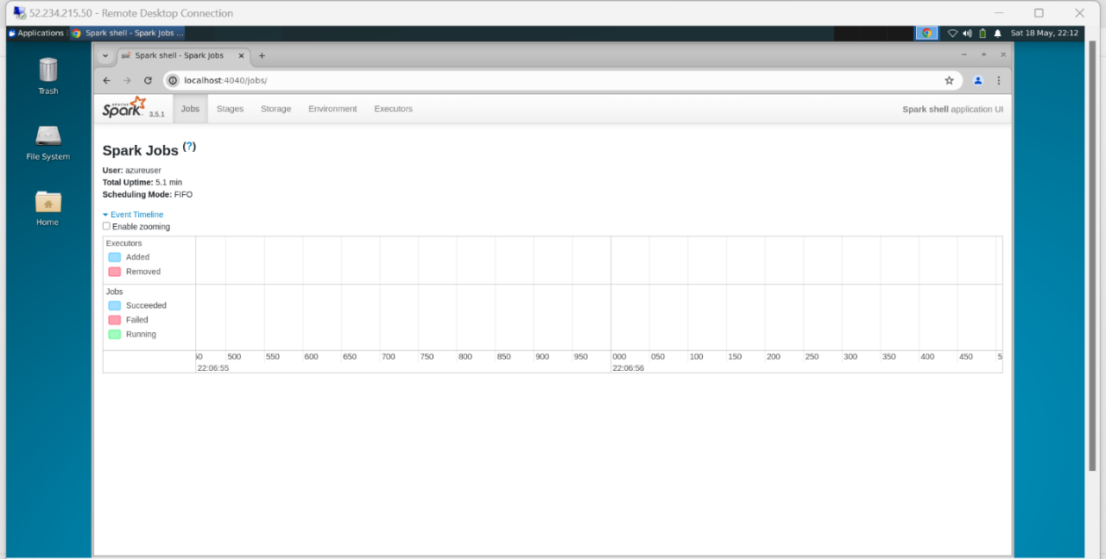
  - Exit from scala-spark (:q)

Task 4.2: Install PySpark
- PySpark is already included, if you have setup Spark in the above method.
Reference: https://spark.apache.org/docs/latest/api/python/getting_started/install.html#manually-downloading
- Ensure the SPARK_HOME environment variable points to the directory where the tar file has been extracted. Update PYTHONPATH environment variable such that it can find the PySpark and Py4J under SPARK_HOME/python/lib.
- So, to update the PYTHONPATH environment variable, open the .profile file with nano:

- And update the python path by adding the following lines:
# update python path for pySpark
export PYSPARK_PYTHON="/usr/bin/python3"
export PYTHONPATH="$SPARK_HOME/python/lib/pyspark.zip:$PYTHONPATH"
export PYTHONPATH="$SPARK_HOME/python/lib/py4j-0.10.9.7-src.zip:$PYTHONPATH"
- Press Ctrl+s to save and Ctrl+x to exit
- Reload the .profile file:
source .profile
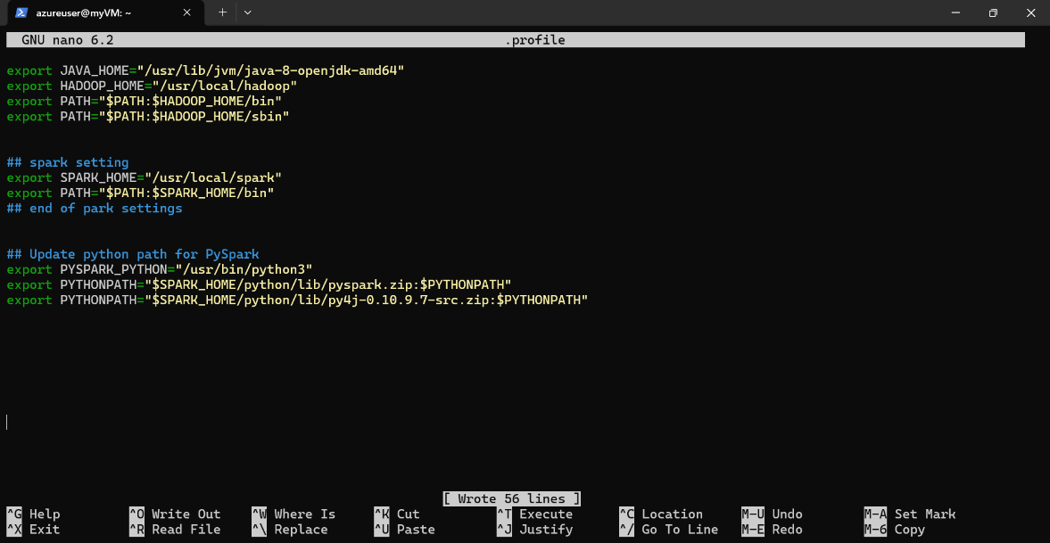
- Ensure that py4j version matches the version in your system. In my case it is py4j-0.10.9.7-src.zip. You can check the version by using the following command:
ls $SPARK_HOME/python/lib
- If everything is ok, then pyspark should be available. Open the python shell:
python3
- Then test importing pyspark inside the shell: (line by line…)
import pyspark
from pyspark.sql import SparkSession
spark = SparkSession.builder.getOrCreate()
exit()
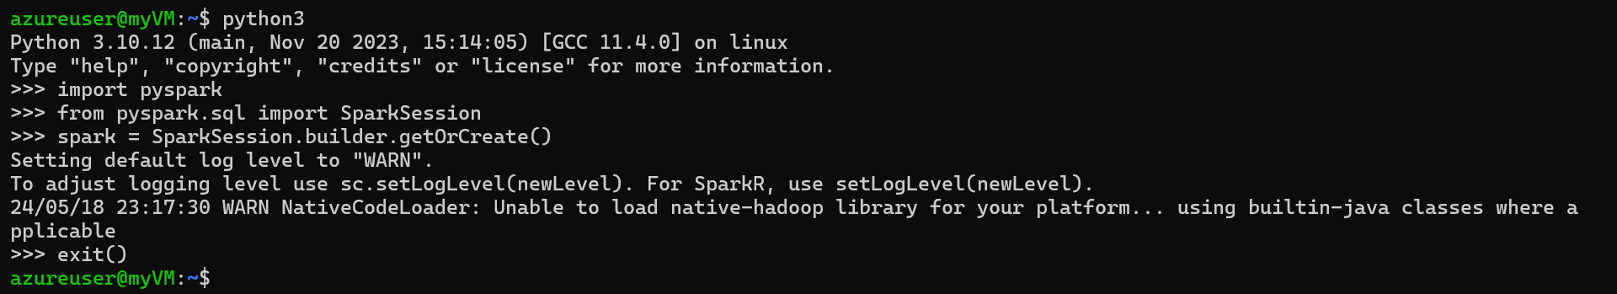

Task 4.3: Install Jupyter Notebook
- Install pip with the following command:
sudo apt install python3-pip
- Install Jupyter:
sudo pip install -U jupyterlab
- Now we need to configure the JupyterLab Server and run it as a daemon. First let us generate a password hash. I am using “mypassword” as Jupyterlab password and generate the hash with the following command:
python3 -c "from jupyter_server.auth import passwd; print(passwd('mypassword'))"
- Copy the generated hash and save it for later use. In my case I have a hash like:
- argon2:$argon2id$v=19$m=10240,t=10,p=8$zPzKLdcEFfKjzwgM5kNzIg$he8brqaOXJk6Dn7cNispocmQa31tTpHhUjWwLZi1+QkYou should have something similar.
- Next, we need to create new directories to organize the Jupyter environment:
mkdir /home/azureuser/jupyter-env
mkdir /home/azureuser/jupyter-env/notebooks
- Create a JupyterLab configuration file with nano editor:
nano /home/azureuser/jupyter-env/config.py
- Add the following python code:
from jupyter_server.auth.identity import PasswordIdentityProvider
c.ServerApp.allow_remote_access = True
c.ServerApp.allow_origin = '*'
c.ServerApp.root_dir = "/home/azureuser/jupyter-env/notebooks"
PasswordIdentityProvider.hashed_password = ''''
- Make sure to use the hash you generated earlier for the PasswordIdentityProvider.hashed_password variable.
- Press Ctrl+s to save and Ctrl+x to exit.
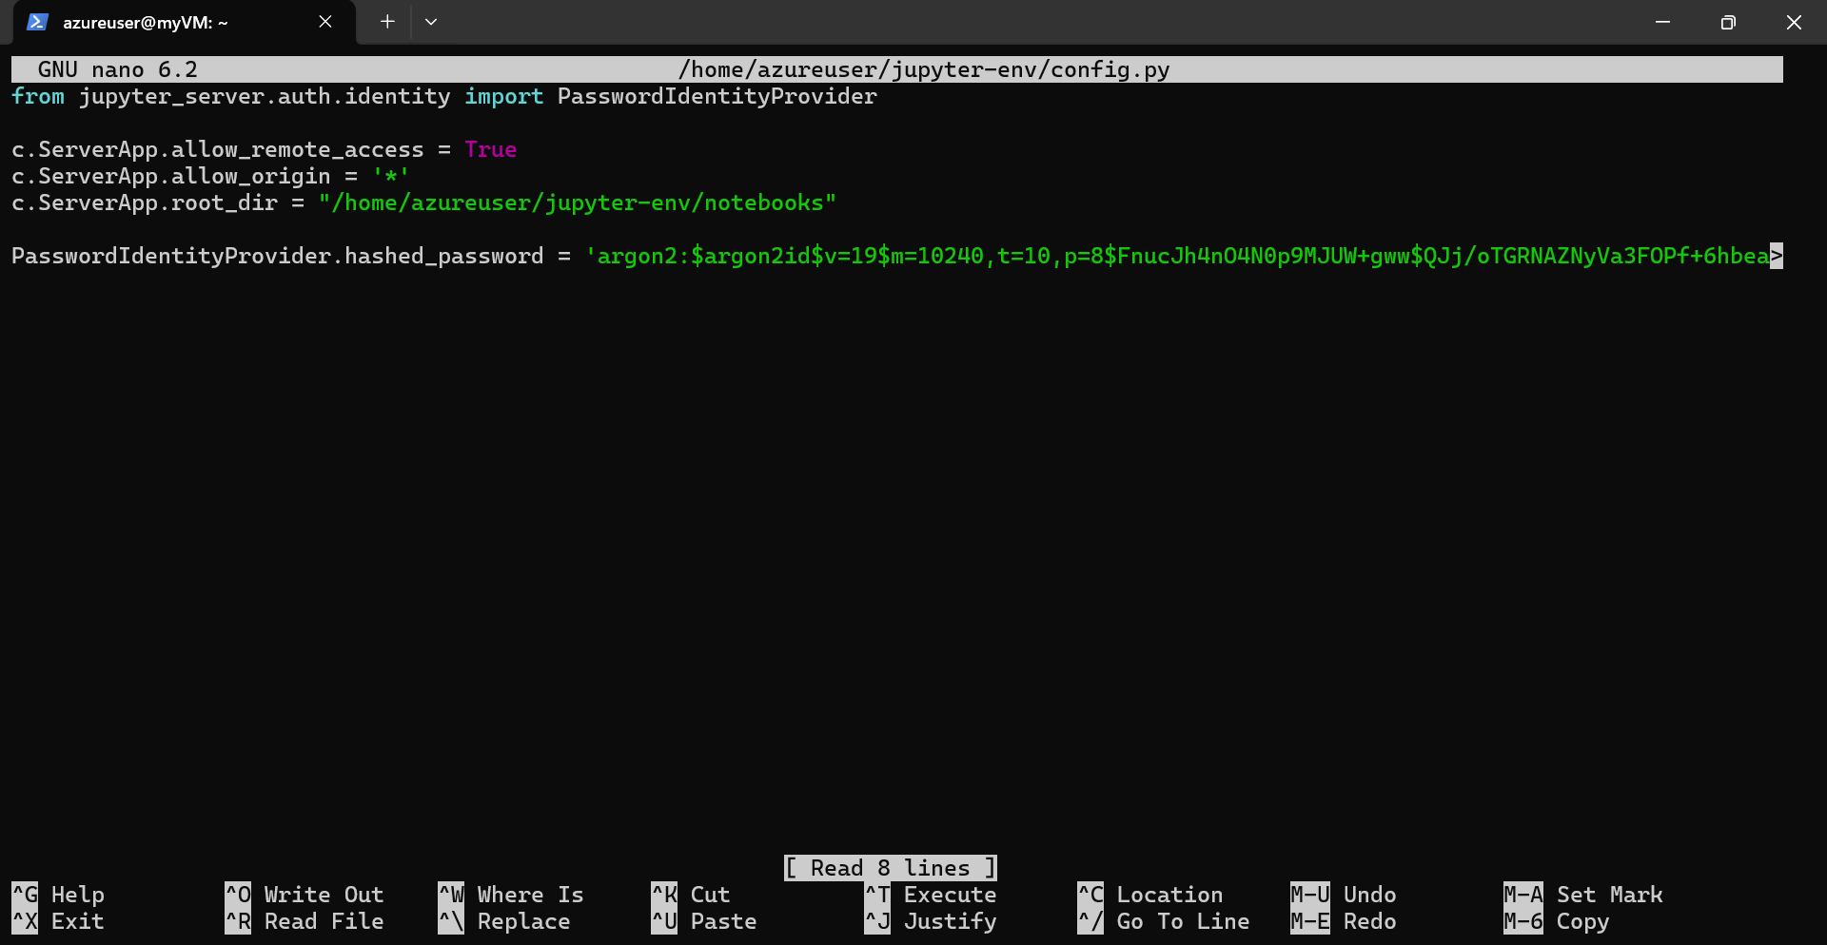

- Run the JupyterLab server:
jupyter lab --ip 0.0.0.0 --config /home/azureuser/jupyter-env/config.py
- Now, connect to VM with remote desktop from your pc:


- Inside the VM desktop check if Jupyter Lab is available at localhost:8888. If prompted for password, input the password you set earlier (in my case it is “mypassword”)

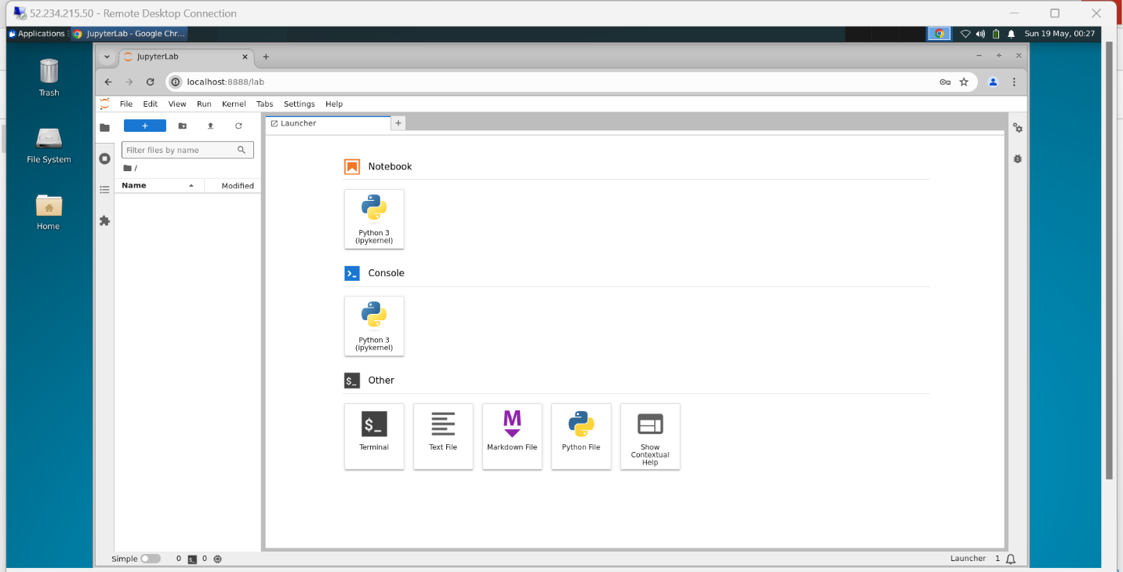

- Now go back to the ssh terminal where Jupyter is running and press Ctrl+c to stop the server.
- Next, we will configure the Jupyter server to run as a daemon (background service). For that find the paths for python and jupyter:
which python3
which jupyter
- In my case the commands give the values- “/usr/bin/python3” and “/usr/local/bin/jupyter”. Note these values for later use:
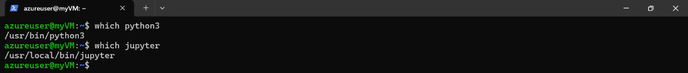
- Next, create a new service named jupyterlab:
sudo nano /lib/systemd/system/jupyterlab.service
- Add the following content with appropriate values for your case:
[Unit]
Description=JupyterLab Server

[Service]
User=azureuser
Group=azureuser
ExecStart=/usr/bin/python3 /usr/local/bin/jupyter lab --config=/home/azureuser/jupyter-env/config.py

[Install]
WantedBy=multi-user.target
- Press Ctrl+s to save and Ctrl+x to exit.
- Initialize the jupyterlab service:
sudo systemctl daemon-reload
sudo systemctl start jupyterlab
sudo systemctl enable jupyterlab
sudo systemctl status jupyterlab
- Press Ctrl+c to exit
- Inside the VM desktop check if Jupyter Lab is available at localhost:8888. If prompted for password, input the password you set earlier (in my case it is “mypassword”)
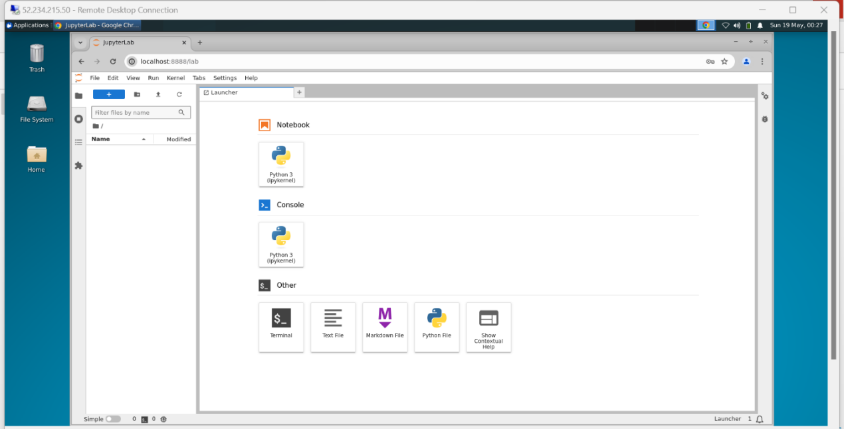

Task 4.4: Prepare PySpark for Jupyter Notebook
- Generally when you install python packages with “pip”, it installs them inside the site-packages directory of your python installation and are available on “sys.path” by default. But if you remember, in our case we installed Spark from a binary distribution and PySpark was included with it. So, PySpark isn't available on sys.path by default. You can address this by either symlinking pyspark into your site-packages, or adding pyspark to sys.path at runtime. There is a python package named “findspark” which does the latter.
- Let us install “findspark” so that pyspark can be imported in our Jupyter Notebooks:
pip install findspark
- That’s it. Now you can import pyspark in your notebooks by initializing it with findspark at run time.

Task 4.5: Prepare jupyter Notebook for MySQL and AzureSQL connections
Python needs the relative JAR files to connect to various containers, in this course, we are going to connect MySQL and AzureSQL, here are the steps to connect.
Remote Desktop to Ubuntu Machine, click on Application ->file Manager
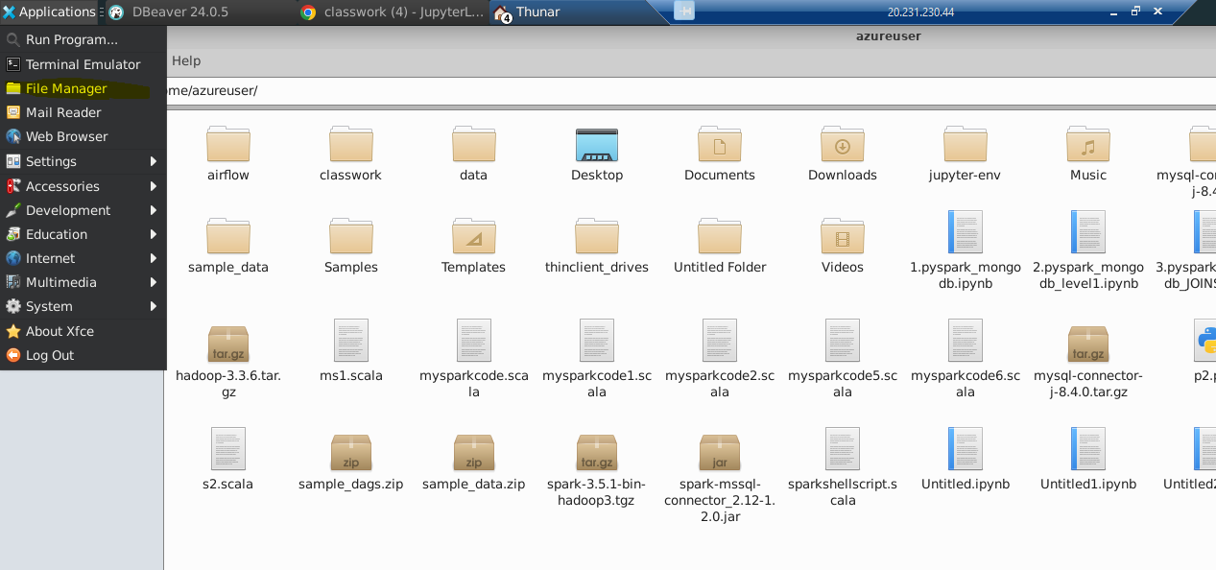
Go to /usr/local/spark/jars/
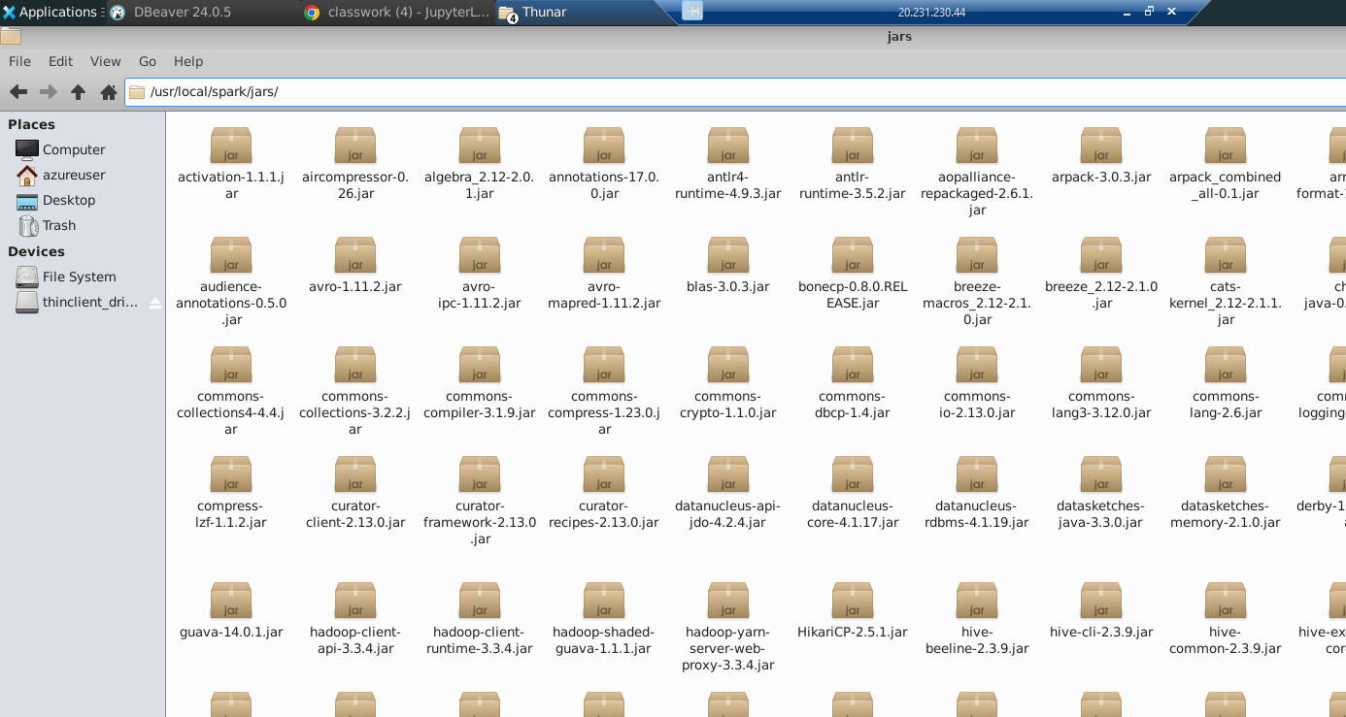

And copy and paste both .JAR files from your local machine to Hadoop machine
- mysql-connector-java-8.0.30.jar
- spark-mssql-connector_2.12-1.2.0.jar

https://github.com/minrk/findspark

Activity 5: Install and configure MS SQL Server /Azure SQL Server and Setup Dbeaver

Task 5.1: Install SQL Server
- Reference: https://learn.microsoft.com/en-us/sql/linux/quickstart-install-connect-ubuntu?view=sql-server-ver16&tabs=ubuntu2204
- We will follow the instructions for installing mssql-server-2022 on Ubuntu 22
- Download the public key, convert from ASCII to GPG format, and write it to the required location:
curl https://packages.microsoft.com/keys/microsoft.asc | sudo tee /etc/apt/trusted.gpg.d/microsoft.asc (write in a single line, not two lines)
- Manually download and register the SQL Server Ubuntu repository:
curl -fsSL https://packages.microsoft.com/config/ubuntu/22.04/mssql-server-2022.list | sudo tee /etc/apt/sources.list.d/mssql-server-2022.list (write in a single line, not two lines)
- Run the following commands to install SQL Server:
sudo apt-get update
sudo apt-get install -y mssql-server
- After the package installation finishes, run mssql-conf setup and follow the prompts to set the SA password and choose Express edition.
- Remember for password, you need a minimum length 8 characters, including uppercase and lowercase letters, base-10 digits and/or non-alphanumeric symbols. I am using “MyP@55word” in this example setup
sudo /opt/mssql/bin/mssql-conf setup
- Select 3 (Express)
- Once the configuration is done, verify that the service is running:
systemctl status mssql-server --no-pager

Task 5.2: Install SQL Server command-line tools
- To create a database, you need to connect with a tool that can run Transact-SQL statements on SQL Server. The following steps install the SQL Server command-line tools: sqlcmd utility and bcp utility.
- Import the public repository GPG keys:
curl https://packages.microsoft.com/keys/microsoft.asc | sudo tee /etc/apt/trusted.gpg.d/microsoft.asc (write in a single line, not two lines)
- Register the Microsoft Ubuntu repository:
curl https://packages.microsoft.com/config/ubuntu/22.04/prod.list | sudo tee /etc/apt/sources.list.d/mssql-release.list (write in a single line, not two lines)
- Update the sources list and run the installation command with the unixODBC developer package:
sudo apt-get update
sudo apt-get install mssql-tools18 unixodbc-dev
- You may need to type YES couple of times, however, make sure you never restart the VM ,
  - When asked, just click enter (don’t restart)
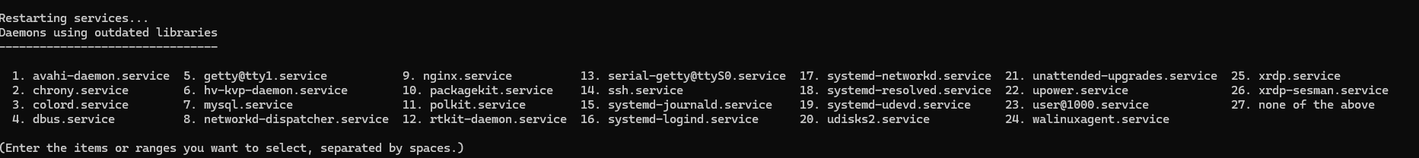
- To make sqlcmd and bcp accessible from the bash shell for login sessions, modify your PATH in the ~/.profile file:
echo 'export PATH="$PATH:/opt/mssql-tools18/bin"' >> ~/.profile
- Press Ctrl+s to save and Ctrl+x to exit. Then reload the .profile file:
source ~/.profile
- Connect locally to your mssql-server. Newer versions of sqlcmd are secure by default. For more information about connection encryption, see connecting with sqlcmd for Linux. We are going use the -C flag: "Trust Server Certificate" for connecting to localhost:
sqlcmd -S localhost -U sa -C
- When prompted, provide the password you set earlier. In my case it is “MyP@55word”
- You have now entered the sqlcmd prompt. Type “QUIT” to exit from the prompt:

Task 5.3: Prepare a AdventureWorks sample database
- Reference: https://learn.microsoft.com/en-us/sql/samples/adventureworks-install-configure?view=sql-server-ver16&tabs=tsql
- We will download the AdventureWorks 2022 database and restore it on our MS SQL server. For that let us create a backup directory:
sudo mkdir /var/opt/mssql/backup
sudo chown -R mssql:mssql /var/opt/mssql/backup
- Now, let us download the sample AdventureWorks2022 database:
cd ~
wget https://github.com/Microsoft/sql-server-samples/releases/download/adventureworks/AdventureWorks2022.bak
- After downloading, move the file to your backup location and give permissions:
sudo mv AdventureWorks2022.bak /var/opt/mssql/backup/
sudo chown -R mssql:mssql /var/opt/mssql/backup/
sudo chmod 770 -R /var/opt/mssql/backup/
- To restore the sample database to SQL Server, first connect with sqlcmd:
sqlcmd -S localhost -U sa -C
- Now run the following lines one by one in the sqlcmd prompt:
USE [master];
GO
RESTORE DATABASE [AdventureWorks2022]
FROM DISK = '/var/opt/mssql/backup/AdventureWorks2022.bak'
WITH
MOVE 'AdventureWorks2022' TO '/var/opt/mssql/data/AdventureWorks2022_Data.mdf',
MOVE 'AdventureWorks2022_log' TO '/var/opt/mssql/data/AdventureWorks2022_log.ldf',
FILE = 1,
NOUNLOAD,
STATS = 5;
GO
- After completing the above commands, you should see a success message:
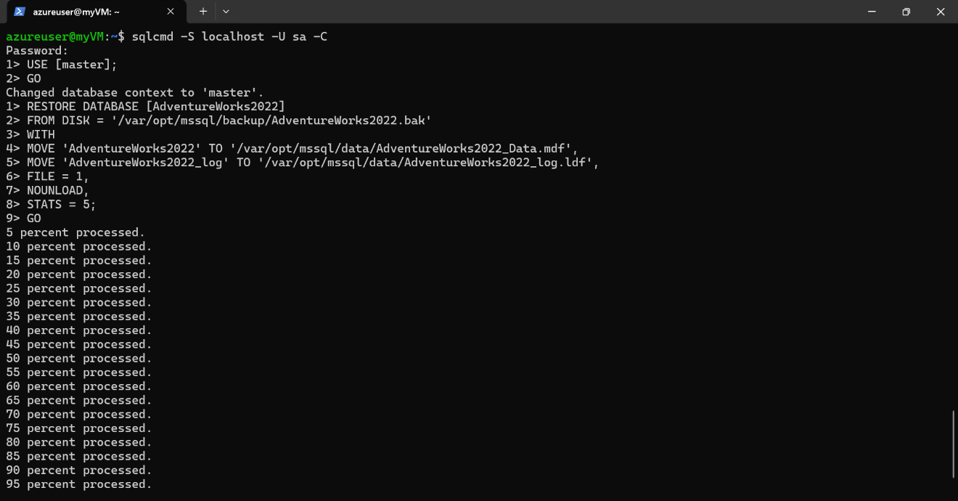
- Next, confirm that the AdventureWorks database is available by running the following query:
SELECT name FROM sys.databases;
GO
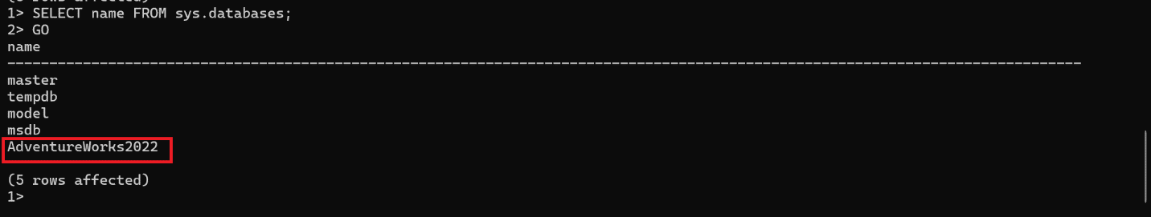
- Type QUIT to exit from the sqlcmd prompt.

Task 5.4: Connect to SQL Server - Dbeaver
RDP to ubuntu server.

- Connect to SQL Server
- Menu - > Database->New Database Connection ->SQLServer
  - Host : localhost
  - Port : 1433
  - Username : sa
  - Password : your password
You will see AdventureWorks2022

Task 5.5: setup AzureSQL
Open WindowsPowerShell (not SSH)
az login
=====================================================================
Now create a resource group. AzureSQL is very expensive , please delete the entire resource group once done testing
az group create --name alinizartraining2 --location eastus --tags Name=Nizar Environment=Training
=====================================================================
Now create AzureSQL Server inside the resource group, please note the username and password
az sql server create --name alinizarserver --resource-group alinizartraining2 --location eastus --admin-user azureuser --admin-password Ilove85workWonder69
=====================================================================
Now create firewall rule
az sql server firewall-rule create --resource-group alinizartraining2 --server alinizarserver -n AllowYourIp --start-ip-address 0.0.0.0 --end-ip-address 0.0.0.0
=====================================================================
Now create a database on the SQL Server with sample data based on adventureworks
az sql db create --resource-group alinizartraining2 --server alinizarserver --name myfirstdatabase --sample-name AdventureWorksLT --edition GeneralPurpose --family Gen5 --capacity 2 --zone-redundant true
Task 5.5: Connect to Azure SQL Server - Dbeaver
RDP to ubuntu server.

- Open Dbeaver
- Menu - > Database->New Database Connection ->AzureSQL
  - Host : alinizarserver.database.windows.net
  - Database/Schema : myfirstdatabase
  - Authentication : SQL Server Authentication
  - UserName : azureuser
  - Password : Ilove85workWonder69

You will see myfirstdatabase

Activity 6: Create a MongoDB Atlas free account

Task 6.1: Create a MongoDB Atlas free account
- Create a free MongoDB Atlas account if you already don’t have one: https://www.mongodb.com/lp/cloud/atlas/try4
- After login, explore the options and you should see that an example cluster is already set up for you. If not, then spin up a new cluster.
- Click the “connect” button on the Database menu:
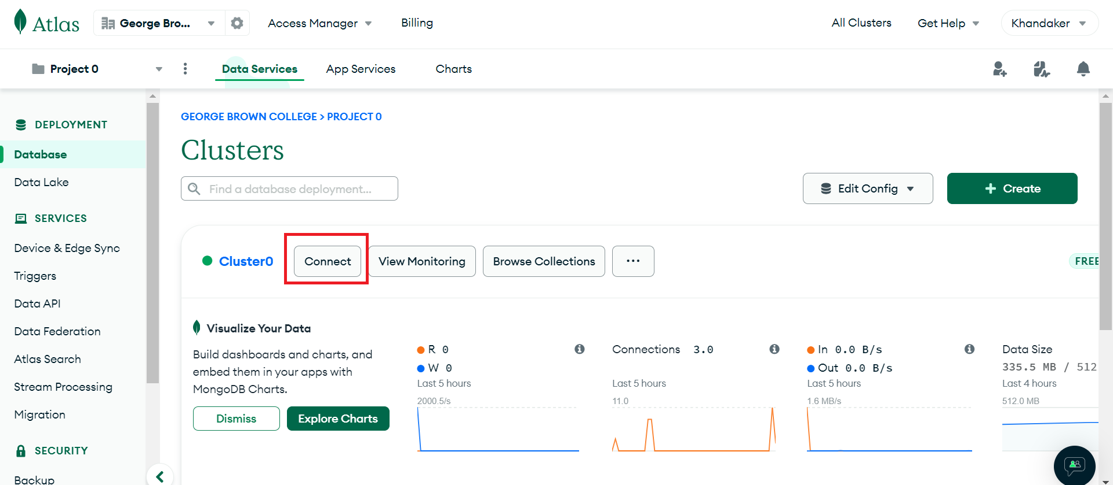
- This should popup an options window. Select the “Connect to your application>>Drivers” link and then find the appropriate option for your system. In our case we will be using Python >= 3.6 and pymongo driver. Also note the other instructions for connecting from your application:
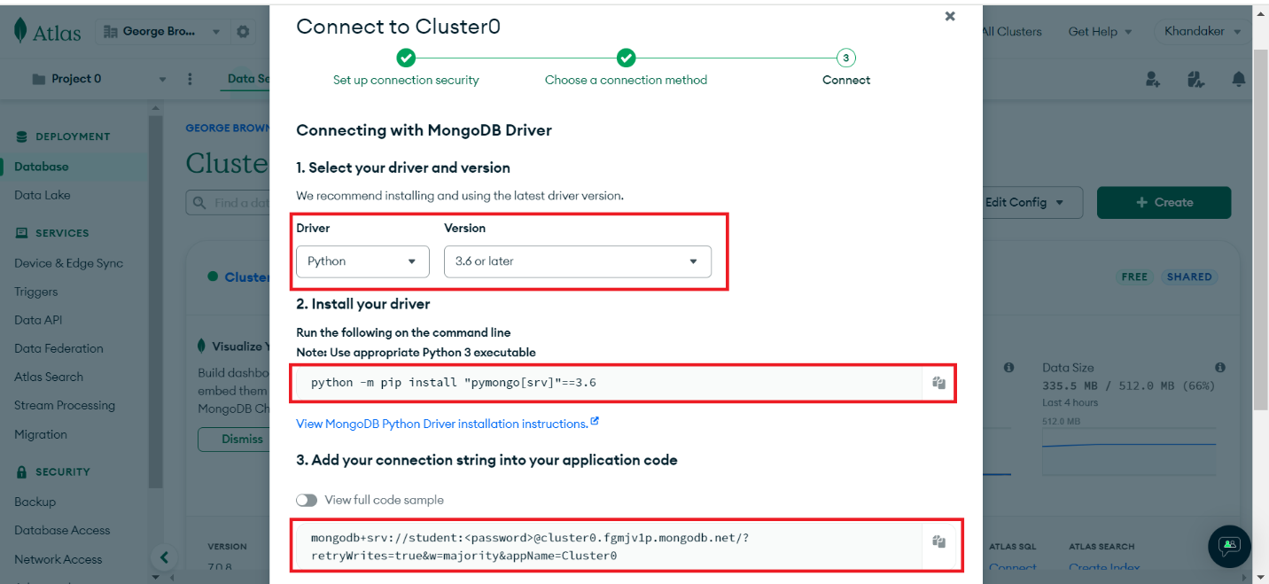

Activity 7: Install and configure Apache Airflow

Task 7.1: Install Apache Airflow
- If you have previously scheduled any jobs in Linux, you probably know about “Cron”. Apache Airflow is sometimes called “Cron on Steroids”. But it is much more than that. The Apache Airflow platform allows you to create, schedule and monitor workflows through programming. You can find more information in the following link:
https://airflow.apache.org/docs/apache-airflow/stable/core-concepts/overview.html
- We will install Airflow from PyPI with pip. Run the following command with the appropriate Python version of your system. In my case it is python 3.10.
pip install "apache-airflow[celery]==2.9.1" --constraint https://raw.githubusercontent.com/apache/airflow/constraints-2.9.1/constraints-3.10.txt
- Next, set the AIRFLOW_HOME variable in the .profile file:
nano .profile
- Append the following line at the end of the file:
export AIRFLOW_HOME="/home/azureuser/airflow"
- Press Ctrl+s to save and Ctrl+x to exit the editor
- Reload the .profile file.
source .profile
- Next, initialize the Airflow database with the following command:
airflow db init
- This will create a sqlite database and configuration files in your home directory. In my case it is “/home/azureuser/airflow”
- You can check the contents with the following command:
ls -a ~/airflow
- Now create an admin user for Airflow:
airflow users create --username admin --firstname bigdata --lastname lab --role Admin --email admin@domain.com
- When prompted for password, provide a password. In my case the password is “mypassword”.
- Now test if you can run the server on localhost:9999 by using the following command:
airflow webserver -p 9999
- Now, connect to VM with remote desktop from your pc:


- Inside the VM desktop check if Airflow Web UI is available at localhost:9999. In the login page use admin as userame and the password you set in the previous step (mypassword)
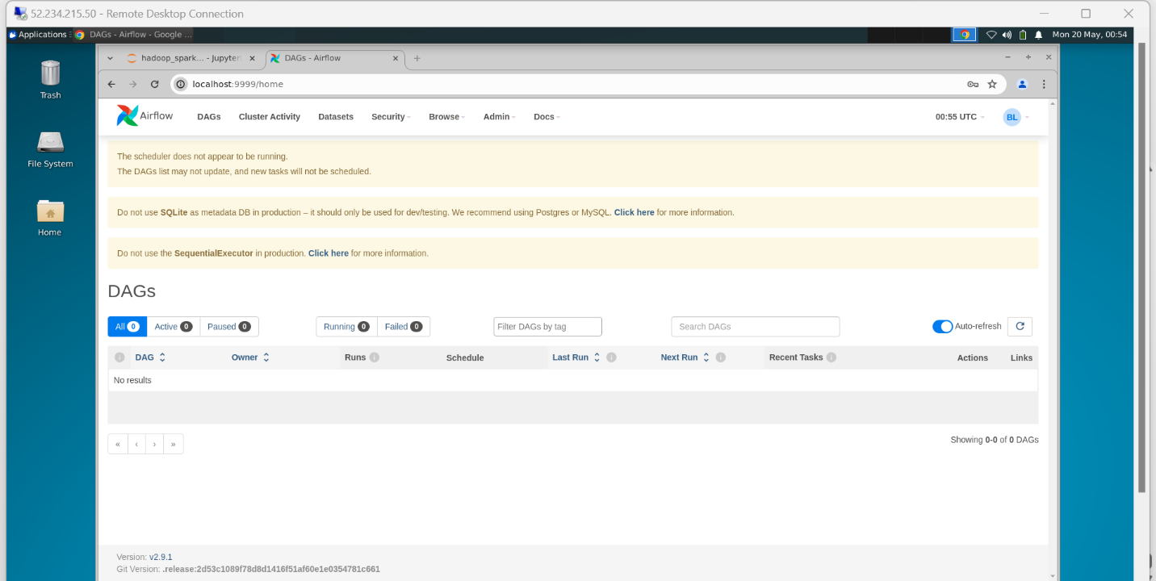
- Now go back to you ssh terminal and shutdown the airflow server by pressing Ctrl+c
- Next create a folder inside the airflow home for keeping your DAGs:
mkdir /home/azureuser/airflow/dags
- Now type the following command to get the location of your airflow executable. We will use it later for creating airflow service:
which airflow
- In my case the airflow executable is located at “/home/azureuser/.local/bin/airflow”
- Next, create a new service named airflow-webserver:
sudo nano /lib/systemd/system/airflow-webserver.service
- Add the following content with appropriate values for your case:
[Unit]
Description=Airflow Webserver
[Service]
User=azureuser
Group=azureuser
Environment="PATH=/home/azureuser/.local/bin:$PATH:/usr/local/bin:/bin:/usr/bin:/usr/local/sbin:/usr/sbin"
ExecStart=/home/azureuser/.local/bin/airflow webserver -p 9999
[Install]
WantedBy=multi-user.target
- Press Ctrl+s to save and Ctrl+x to exit the editor
- Initialize the Airflow Webserver service:
sudo systemctl daemon-reload
sudo systemctl start airflow-webserver
sudo systemctl enable airflow-webserver
sudo systemctl status airflow-webserver --no-pager
- Now go back to your VM dektop session and check that airflow is running by refreshing the url:
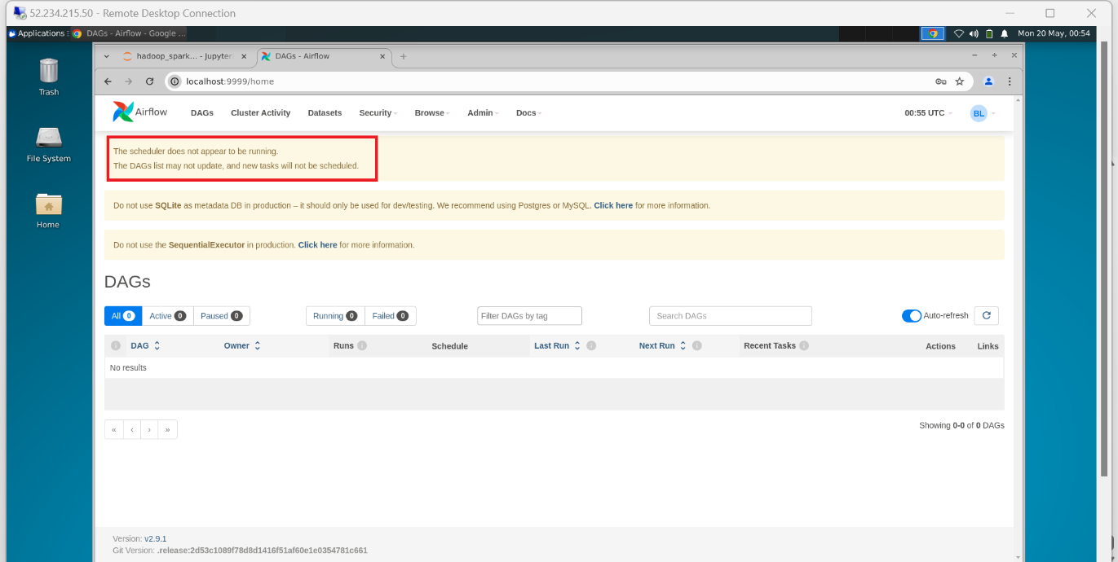

Task 7.2: Configure Apache Airflow Scheduler
- Notice that in your Airflow Web UI there is a warning message “The scheduler does not appear to be running”.
- So, we need to create a service for running the scheduler. Open a file in nano editor in your ssh terminal:
sudo nano /lib/systemd/system/airflow-scheduler.service
- Add the following content with appropriate values for your case:
[Unit]
Description=Airflow Scheduler
[Service]
User=azureuser
Group=azureuser
Environment="PATH=/home/azureuser/.local/bin:$PATH:/usr/local/bin:/bin:/usr/bin:/usr/local/sbin:/usr/sbin"
ExecStart=/home/azureuser/.local/bin/airflow scheduler
[Install]
WantedBy=multi-user.target
- Press Ctrl+s to save and Ctrl+x to exit the editor.
- Initialize the Airflow Scheduler service:
sudo systemctl daemon-reload
sudo systemctl start airflow-scheduler
sudo systemctl enable airflow-scheduler
sudo systemctl status airflow-scheduler --no-pager
- Now if you go back to the Airflow Web UI, you should see that the warning message disappeared:
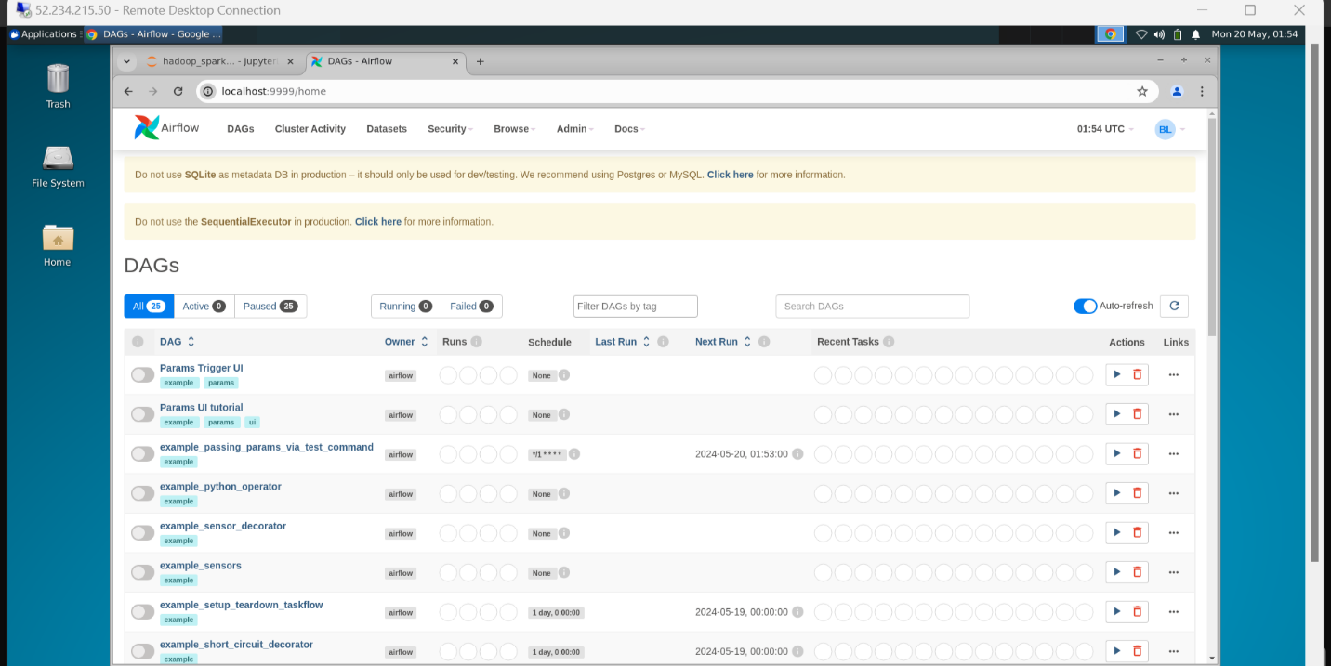
- Your Airflow is ready to deploy DAGs.
- You can learn more about Airflow from the following link:
https://www.youtube.com/watch?v=K9AnJ9_ZAXE&list=PLwFJcsJ61oujAqYpMp1kdUBcPG0sE0QMT&index=1

Activity 8: Create data pipelines with Apache Airflow and PySpark

Task 8.1: Upload sample data to your VM
- I have provided a sample_data.zip file. You need to upload it to your VM from your PC. In my case the sample_data.zip is in my windows Downloads folder.
- Let us open a new PowerShell terminal and change directory to Downloads:
cd ~\Downloads
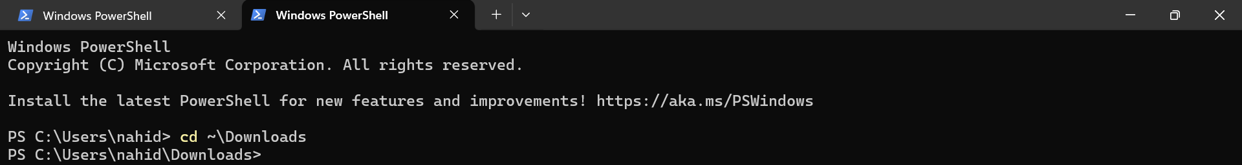
- Now upload the sample_data.zip file with scp to your VM’s home folder (use your VM IP address, in my case it is 20.232.160.204):
scp .\sample_data.zip azureuser@20.232.160.204:
- If you ssh into your VM, you should see the sample_data.zip file is available in your home directory. Use the ls command to list directory contents:
ls
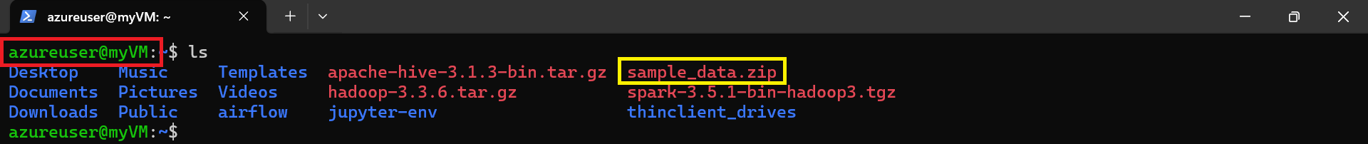
- Now unzip the file and the csv files should be available under the sample_data directory:

sudo apt install zip
unzip sample_data.zip
ls
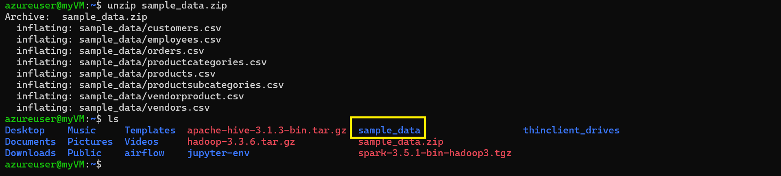
- Now check the available csv files inside the sample_data folder. There should be 8 files.
ls -l sample_data/
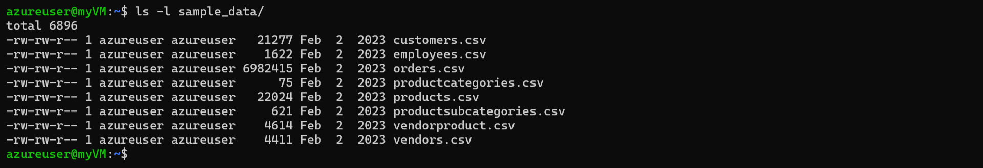

Task 8.2: Upload the sample Airflow DAGs to your VM
- Airflow DAGs are created by placing python scripts inside your airflow dags folder.
- I have provided a sample_dags.zip file which contains the python scripts.
- Open the python files in a python IDE like VSCode and go through the codes.
- Next, you need to upload sample_dags.zip file to your VM from your PC. In my case the sample_dags.zip is in my windows Downloads folder.
- Let us open a new PowerShell terminal and change directory to Downloads:
cd ~\Downloads
- Now upload the sample_dags.zip file with scp to your VM’s home folder (use your VM IP address, in my case it is 20.232.160.204):
scp .\sample_dags.zip azureuser@20.232.160.204:
- Now ssh login to your VM, and you should see the sample_dags.zip file is available in your home directory. Use the ls command to list directory contents and unzip the file:
unzip sample_dags.zip
- Now check the available python files inside the sample_dags folder. There should be 4 files for csv, Hive, MongoDB and SQL Server data pipes.
ls -l sample_dags/
- Copy the sample dag files (python scripts) to your airflow dags directory:
mv ~/sample_dags/* ~/airflow/dags/
chmod 774 ~/airflow/dags/ -R
- Now the python scripts should be visible on your Airflow Web UI under the DAGs menu.

Task 8.3: Install necessary Python libraries
- Install python packages with pip:
pip install "pymongo[srv]"==3.10
pip install pandas

Task 8.4: Install Spark JDBC Connector for SQL Server
- Download the driver from maven repo:
cd /usr/local/spark/jars/
wget https://repo1.maven.org/maven2/com/microsoft/azure/spark-mssql-connector_2.12/1.2.0/spark-mssql-connector_2.12-1.2.0.jar
- Now go back to home directory:
cd ~

Task 8.5: Run the uploaded DAGs
- Previously we uploaded the sample DAGs to airflow dags folder. Sometimes it takes a while to see the DAGs in the Web UI. So, let us restart the airflow scheduler service:
sudo systemctl restart airflow-scheduler
- Now, connect to VM with remote desktop from your pc:


- Inside the VM desktop open localhost:9999 for the Airflow Web UI. In the DAGs menu you will find the uploaded sample DAGs:
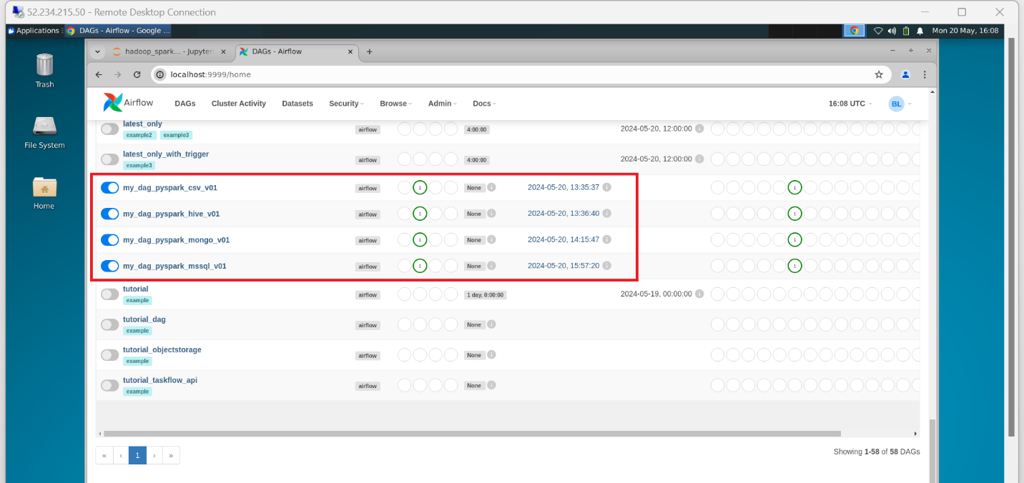
- You can click on any of them, and it will take you to the DAG’s details page. Explore the different options. Click on the Graph tab and it will show you the run status.
- Notice there is also a run icon on the top right corner.
- If you click on the Task in the center of the Graph view and a Logs tab will appear where you can see the logs of your tasks.
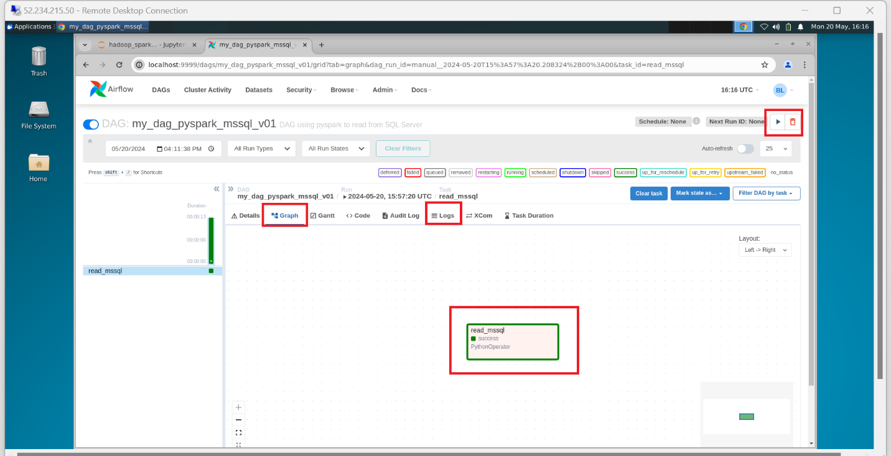
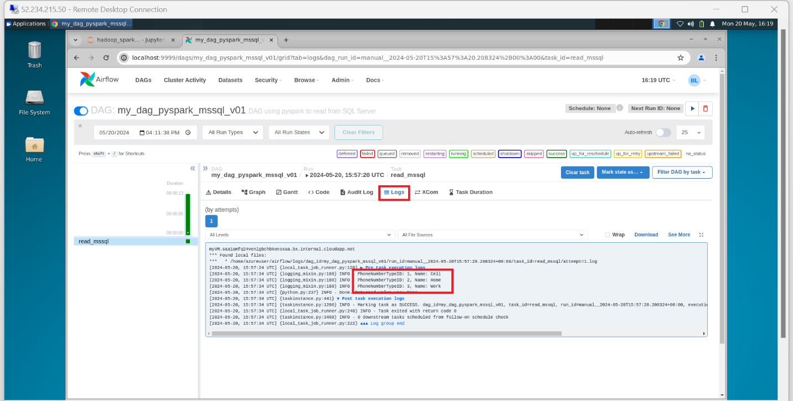

Activity 9: Testing PySpark and Spark-Shell Code

Task 9.0: Load Sample Data
Please run all commands from load sample data in Hadoop(Provided)

Task 9.1: Testing/executing PySpark code using Jupyter Notebook
ssh azureuser@20.232.160.204
pip3 install pandas
jupyter lab
***you will be presented with following
Or copy and paste one of these URLs:
http://localhost:8888/lab?token=072df8652f6a2cf0a2da6293e3246ef826d23f6fef6e5d9b
http://127.0.0.1:8888/lab?token=072df8652f6a2cf0a2da6293e3246ef826d23f6fef6e5d9b
***the token will change for each user

Remote Desktop into your hadoop VM
open browser
paste one of the link (once after you put in the above link, now you are good to use http://127.0.0.1:8888/lab )
**DO NOT CLOSE THE SSH SESSION. BOOKMARK the link !
Open a New Notebook. **copy and paste the code provided in sampledataframe.py

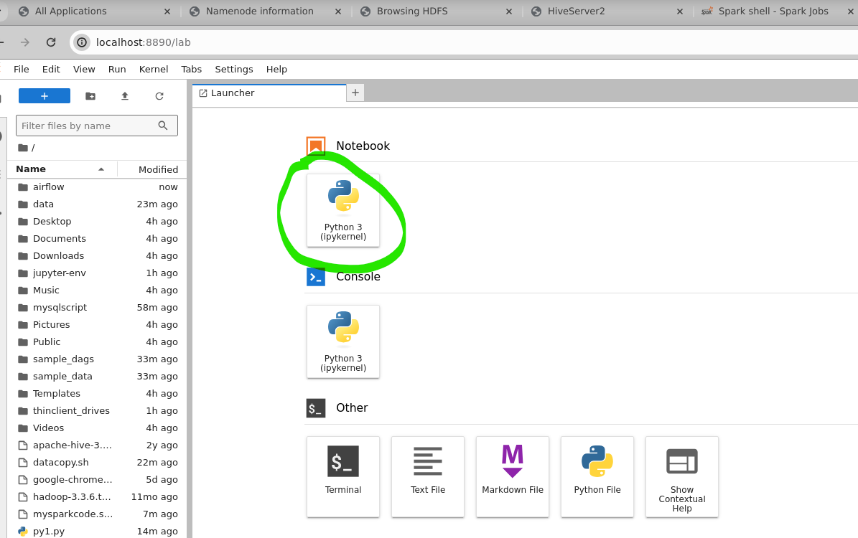
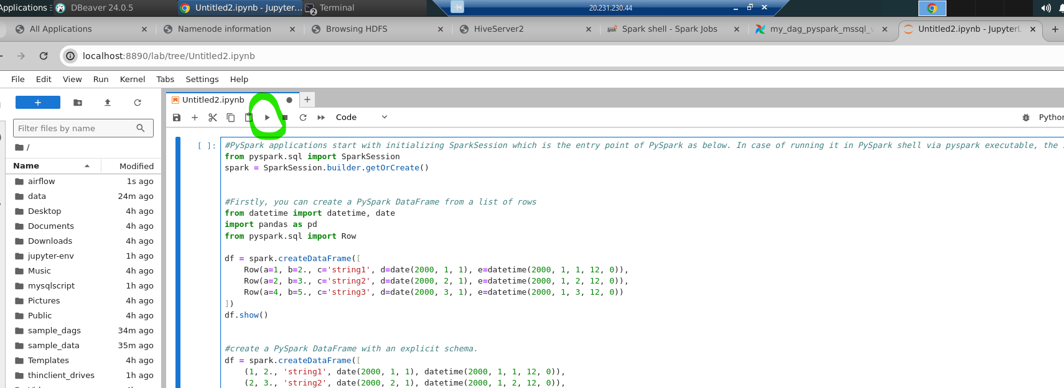

Task 9.2: Testing/executing PySpark code nano
ssh azureuser@20.232.160.204
nano p1.py
**copy and paste the code provided in dataframe_pyspark.py
Following will execute the code
python3 p1.py
you will see following result
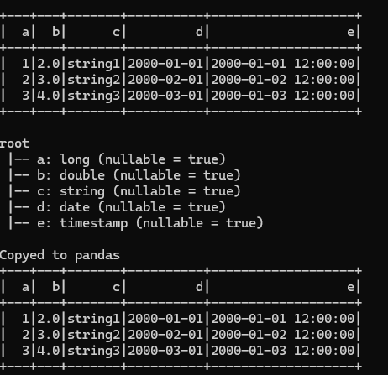

Task 9.3: Testing/executing Spark-Shell
ssh azureuser@20.232.160.204
spark-shell
**above will open spark-shell
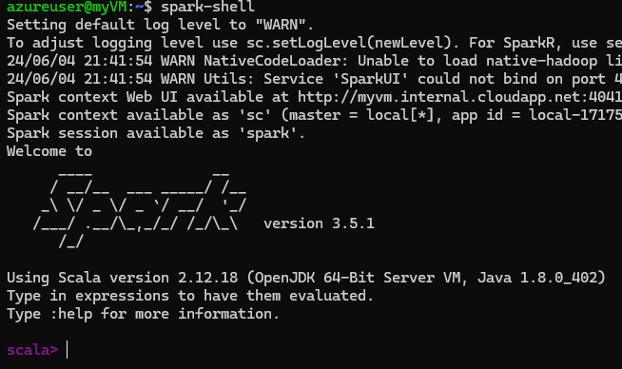
Now copy and paste following line by line
val customersDF = spark.read.format("csv").option("header", "true").load("hdfs://localhost:9000/user/input/adventureworksv2/Customers.csv")
customersDF.printSchema()
customersDF.show()
val sale2015DF = spark.read.format("csv").option("header", "true").load("hdfs://localhost:9000/user/input/adventureworksv2/Sales_2015.csv")
val joinedDF = customersDF.join(sale2015DF, "CustomerKey")
joinedDF.printSchema()
joinedDF.show()

Task 9.4: Testing/executing Spark-Shell-script
ssh azureuser@20.232.160.204
nano sparkshellscript.scala
**append code provided in sparkshellscript.scala
spark-shell -I sparkshellscript.scala
:quit

Activity 10 : Very Important

Very important
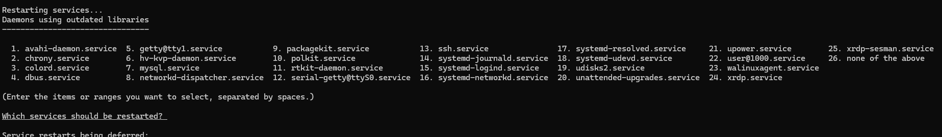
Anytime, you are asked to restart. Make sure you NEVER RESTART. Just hit enter

